FIFTEEN SHARDS OF LIGHT
Level_03_Art_Production_Bible_v1.1
Boundary Map • Layer Split • Asset Registry • Blender → GLB → Godot Integration
«После наших разговоров»
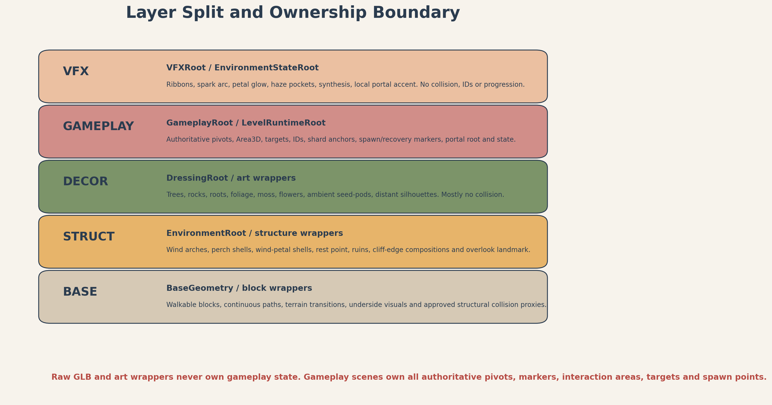
Production-layer overview. The gameplay layer remains authoritative; art layers are replaceable.
Control | Value
Project | Fifteen Shards of Light
Repository | MindDevastation/fifteen-shards-of-light
Target level | Level_03 only / res://scenes/levels/Level_03.tscn
Document status | ART PRODUCTION DESIGN CANDIDATE v1.1 - Producer approval required
Mode | Documentation only - no Blender files, GLBs, textures, final materials, Godot scenes/wrappers, Greybox Reference, branches, commits or PRs
Authorized next gate | Greybox Development Reference only after Producer approval; no Codex implementation, runtime PR or post-greybox art production is authorized by this document

Version 1.1 Change Log
ID | v1.1 correction
V11-01 | Normalized the complete registry: every real geometry variant is an explicit canonical row, a declared single reusable geometry, or a named internal set with one export strategy.
V11-02 | Replaced wildcard/abbreviated registry paths with separate exact Blender source, raw GLB, collision GLB/Godot primitive and Godot wrapper fields.
V11-03 | Separated GB-P0 proxy input from ART-P1/ART-P2/ART-P3 post-greybox production priority; no final art file is greybox content.
V11-04 | Moved the hard StaticBody boundary belt to EnvironmentRoot/BoundaryRoot or approved block-local collision under EnvironmentRoot; SafetyRoot retains only recovery Area3D/markers.
V11-05 | Added one universal Blender/Godot dimension-axis contract and exact final transform normalization contract.
V11-06 | Split primitive replacement into independent visual-only and collision-proxy swap gates with separate regression and rollback.
V11-07 | Locked zero movement for authoritative gameplay anchors/nodes and defined the exact ±1.5 m dressing tolerance with no clearance reduction.
V11-08 | Resolved SoulOrb_Follow: reuse shared asset with zero Level_03 parent offset; no new Level_03 orb asset or fourth semi-hero family.
V11-09 | Re-exported the Boundary Map as two readable maps with leader lines and separate legends.
V11-10 | Updated layer, collision, wrapper, priority, acceptance and production-gate content consistently with all corrections.

EMOTIONAL SAFETY CONTRACT
The heroine is not broken and is not being repaired. Her light already belongs to her. Environment changes describe the author’s increasing clarity and lightness; they do not create emotional debt, demand an answer, or frame the player as a savior.

0. Document control, source hierarchy and scope

0.1 Four-source authority hierarchy
Priority | Approved source | Authority in this Bible
1 | Level_03_Narrative_and_Level_Scenario_Package.docx | Meaning, emotional safety, exact shard/main texts, narrative order and forbidden readings.
2 | Level_03_Visual_Master_Concept_Package_v1.1.docx | Shape language, visual hierarchy, semi-hero limit, environment-state reading, palette and art-direction guardrails.
3 | Level_03_Gameplay_Map_and_Level_Design_Spec_v1.1.docx | Exact world coordinates, dimensions, route width, puzzle clearances, recovery rules, camera QA points and acceptance constraints.
4 | Level_03_Technical_Architecture_and_State_Model_v1.1.docx | Scene ownership, authoritative gameplay markers/pivots, root-layer split, wrapper boundaries, runtime references and portal/recovery ownership.

Conflict rule
Narrative controls meaning and copy. Visual Master controls art language. Gameplay Spec controls exact coordinates and clearances. Technical Architecture controls ownership and scene boundaries. This Bible defines production decomposition without overriding any of those authorities.

0.2 Current repository snapshot and legacy replacement
Item | Verified snapshot | Production implication
Current Level_03.tscn | SHA 1d8ee50989bbf9d06e8a1fb4f3fe11648b17182b; one LevelManager, one SoulShard, PoemRewardUI, four step platforms, three reveal triggers. | Legacy placeholder only. It does not constrain art decomposition and must not be treated as canonical layout.
AGENTS.md | SHA f0a50cd2710487923f2de649813301a2899a723d; small-slice workflow and no polished assets before a working greybox. | Final art and wrapper integration remain post-greybox.
Shared LevelPortal | Current shared scene owns portal visual, InteractionArea, activation and scene transition. | Level_03 art may provide only a dormant environmental setting and local accent VFX; no custom portal state ownership.

• No repository writes were made while producing this Bible.
• No exact runtime NodePaths, scripts, state machines or scene implementations are created here; the Technical Architecture remains authoritative for those details.
• All proposed art paths and names are production contracts for later approved work, not evidence that files already exist.

0.3 Document map
Section | Purpose
1 | Art production verdict and non-negotiable production rules
2 | Boundary Map and clearances
3 | BASE / STRUCT / DECOR / GAMEPLAY / VFX layer split and node ownership
4 | Coordinate, naming, origin and import contracts
5–6 | Complete asset registry, budgets and LOD rules
7–8 | Material/VFX families and production sheets
9–10 | Collision matrix and pivot/marker contracts
11 | Wrapper-first Blender → GLB → Godot pipeline and primitive replacement
12 | Immediate Greybox Handoff
13–16 | Post-greybox slices, priorities, export checklist and acceptance gates
Appendices | Exact production anchors, path plan and final handoff boundary

1. Art production verdict
VERDICT
APPROVE FOR PRODUCER REVIEW AS AN ART-PRODUCTION DESIGN CANDIDATE. The level can be produced with three semi-hero families, shared modular kits and a wrapper-first integration pipeline. No final art may enter the initial greybox PR. The exact S-route, safe clearances, gameplay-owned markers and shared portal contract remain unchanged.

1.1 Locked production principles
• One continuous asymmetrical S-route. Art must never turn the level into a circular hub, arena, shrine or challenge bowl.
• Exactly three semi-hero visual families: Wind_Arch_Family, SeedPod_Perch_Family and Wind_Petal_Family.
• Final Overlook, ruin clusters and Rest Point are compositions from modular kits, not additional hero families.
• Gameplay scenes exclusively own authoritative pivots, interaction areas, IDs, targets, shard anchors, spawn/recovery markers and portal root.
• Raw GLB and art wrappers own only presentation: meshes, approved static collision, materials, presentation-only animation and non-authoritative ArtAlignment_* markers.
• No imported node name may become a critical gameplay dependency. Art swap must not change the Level_03 gameplay API.
• Positive scale only. A required mirror is applied in Blender and exported as an explicit variant.
• The world is visibly alive and colored in E0. Production cannot rely on a dead/grayscale base asset set.

2. Boundary Map
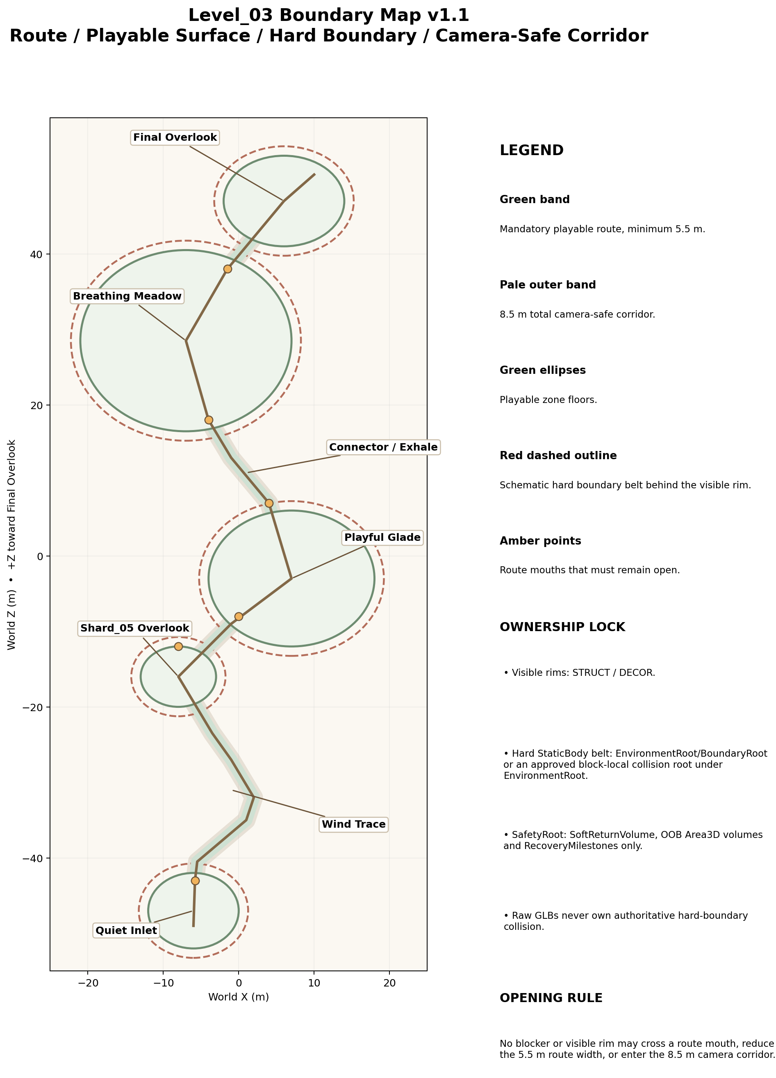
Figure 1A. Route, playable surfaces, hard boundary belt and camera-safe corridor. Hard StaticBody boundary collision is EnvironmentRoot-owned; visible rims are STRUCT/DECOR.

2.1 Boundary classes
Boundary | Location | Size / range | Physical form | Owner | Production rule
Playable surface | All mandatory route and zone floors | 44 × 106 m world envelope; zone footprints per Gameplay Spec | Visible floor + walkable collision | BASE art / Godot block wrapper | Continuous; no gaps >0.10 m; cross-slope <=3°.
Mandatory route corridor | P00–P16 S-route | 5.5 m minimum; 6–7 m at turns, entrances and reward areas | Visible floor | BASE / gameplay design authority | No dense decor or blockers.
Route shoulder | Both sides of mandatory route | 1.5 m minimum beyond walkable edge | Visible, mostly non-walkable dressing buffer | DECOR / Art | Keep free of dense props and camera blockers.
Camera-safe corridor | Around mandatory centerline | 8.5 m total clear corridor | Not visible | Art placement rule | Tall props outside; low plants allowed if silhouette remains clean.
Hard boundary belt | Behind natural cliff/edge composition | 1.0–1.5 m thick; placed behind visual rim | Invisible blocker, supported by visible edge | EnvironmentRoot/BoundaryRoot or approved block-local collision root under EnvironmentRoot | Required StaticBody3D collision behind the visible rim. It never crosses route mouths, puzzle/reward clearances, portal clearance or camera corridor. Raw GLBs do not own this authoritative belt.
Soft visual boundary | Cliff shelves, rocks, roots, low ruins, foliage | Variable; outside shoulder | Visible, primarily non-colliding | STRUCT + DECOR | Reads as natural edge, never as fortress wall.
SoftReturn envelope | Below playable world | One broad explicit Area3D below level | Invisible Area3D | GAMEPLAY / SafetyRoot | No invisible catch floor. Recovery only after entering explicit volume.
Explicit OOB volumes | Known side escape risks only | Authored per location after greybox playtest | Invisible Area3D | GAMEPLAY / SafetyRoot | Must not overlap legal side spaces or overlooks.
Puzzle clearance | Shard/perch/petal centers | 3.0 m clear radius | Not visible | GAMEPLAY authority; Art exclusion zone | No tall props or camera-blocking vertical forms.
Portal clearance | LevelPortalRoot at (10,1.6,50.5) | Minimum 4.5 m clear radius around shared portal footprint | Visible clean floor + shared trigger | GAMEPLAY shared portal / BASE art floor | No overlook prop, landmark arch or local accent may intersect shared InteractionArea.
Decor-only zone | Outside route shoulder and puzzle clearances | Within art envelope and sightline guardrails | Visible | DECOR | No gameplay reliance; removable without progression impact.
No-decoration corridors | Route mouths, arch openings, reward lines, CP0–CP4 sightlines | Per map and QA views | Not visible | Art placement rule | No tall/busy prop that hides next landmark or target.
Art dressing tolerance | Non-authoritative vegetation, ruins and loose decor only | Maximum ±1.5 m from approved art placement | Visible only; no gameplay authority | STRUCT / DECOR | Gameplay anchors, triggers, Area3D nodes, pivots, LevelPortalRoot, recovery anchors and NodePaths have zero movement. No tolerance may reduce route width, 3 m puzzle clearance, R4.5 portal clearance, 8.5 m camera corridor or seam limit <=0.10 m.

2.2 Zone boundary schedule
Zone | Locked footprint | Route openings | Critical clearance | Recovery
Block_03_00 Quiet Inlet | Center (-6,0,-47), 12×10 m oval | 1 broad opening toward P01; no closed rear wall that traps camera | Spawn clear 4 m; CP0 line to Final Overlook preserved | RA0
Block_03_01 Wind Trace | P01–P06, floor Y 0.08–0.80 | Route continuously open through all three arches | Arch internal W >=6.5 m; overhead >=5.2 m | RA1 after route milestone
Block_03_02 Shard05 Overlook | Center (-8,0.9,-16), 10×8 m oval | At least 6 m route opening to glade approach | Shard >=2.5 m from edge; 3 m clear radius | RA2
Block_03_03 Playful Glade | Center (7,1,-3), 22×18 m oval | Entry at P08 and exit at P10 remain broad and obvious | Perch A/B/C each 3 m clear radius; one camera composition | RA3
Block_03_04 Connector | P10–P12, W 5.5–6 m | No new gameplay gate; both ends fully open | Reduced prop density; meadow readable before entry | RA4 at meadow entry
Block_03_05 Breathing Meadow | Center (-7,1.3,28.5), 28×24 m oval | Entry/exit openings remain visually distinct, not ring walls | 3 m around each petal and Rest Point; all targets visible from P12 | RA5
Block_03_06 Final Overlook | Center (6,1.6,47), 16×12 m oval | Approach from P14; horizon remains open | Main_Text_Gate R4.5; portal clear R4.5; CP4 framing preserved | RA6
LOCKED ART TOLERANCE
Authoritative gameplay anchors, triggers, Area3D nodes, pivots, shard anchors, LevelPortalRoot / PortalFloorAnchor, recovery anchors and NodePaths: 0.00 m movement. Non-authoritative visual dressing may move only within the approved Gameplay Design tolerance of ±1.5 m, and only when route width, puzzle/portal clearance, camera corridor, sightlines and block seams remain compliant. Block seams remain <=0.10 m.

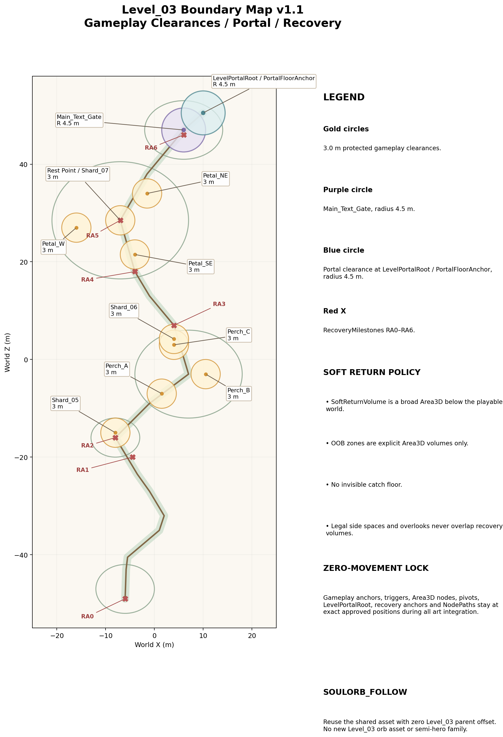
Figure 1B. Gameplay clearances, Main_Text_Gate, LevelPortalRoot / PortalFloorAnchor and recovery anchors. SafetyRoot owns recovery only; no invisible catch floor.
NO INVISIBLE CATCH FLOOR
Optional underside collision may exist only directly beneath visible walkable geometry to prevent tunneling. It may not bridge visual gaps, extend playable space, or prevent the player from reaching SoftReturnVolume.

3. Layer split and node ownership
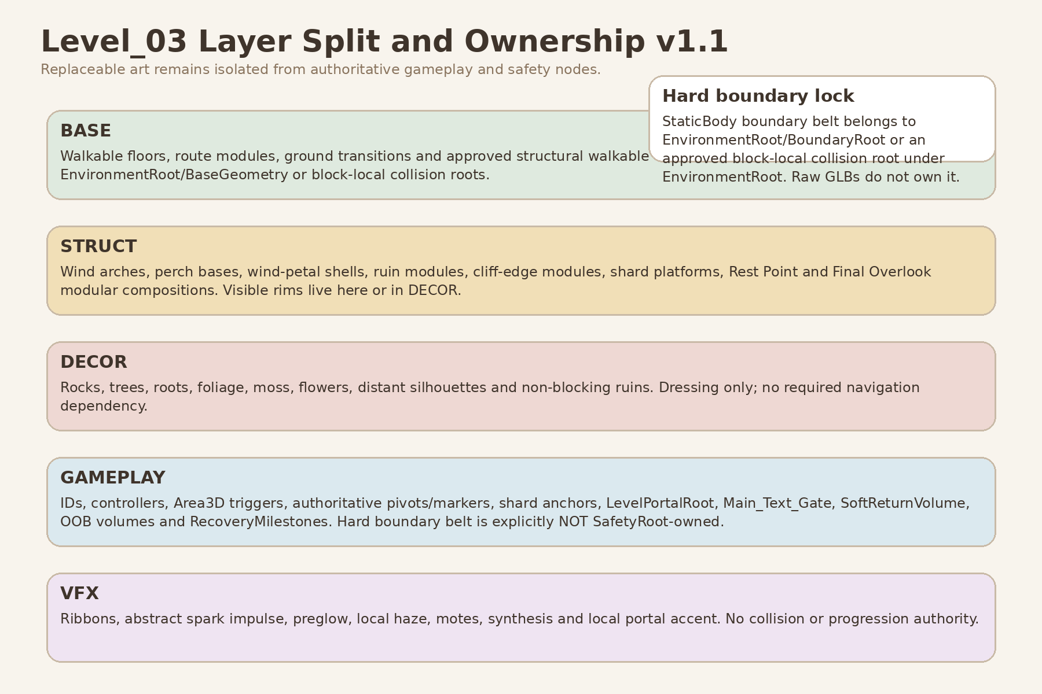
Figure 3. Layer split and ownership v1.1. The hard StaticBody boundary belt is EnvironmentRoot-owned; SafetyRoot owns recovery Area3D volumes and recovery markers only.
Layer | Contains | Scene owner | Explicitly must not own
BASE | Terrain/platform floors, route modules, ground transitions, visible undersides, basic elevation, approved walkable collision and the hard StaticBody boundary belt. | EnvironmentRoot/BaseGeometry, EnvironmentRoot/BoundaryRoot, and approved block-local collision roots under EnvironmentRoot | Gameplay IDs, interaction triggers, puzzle state, portal state or recovery logic.
STRUCT | Wind arches, perch bases, wind-petal shells, ruin modules, cliff-edge modules, shard platforms, Rest Point dais and Final Overlook modular composition. Visible rims belong here or in DECOR. | EnvironmentRoot/LandmarkRoot or block wrappers | Authoritative rotation/petal pivots, landing targets, portal root, interaction areas.
DECOR | Rocks, roots, trees, bushes, grass, flowers, moss, hanging vines, distant silhouettes and non-blocking ruins. | EnvironmentRoot/DressingRoot or art-only children of wrappers | Any gameplay state or required navigation dependency.
GAMEPLAY | Area3D interaction/crossing/dwell triggers, canonical IDs, controllers, authoritative pivots/markers, shard anchors, spawn markers, Main_Text_Gate, LevelPortalRoot, SoftReturnVolume, OOB volumes and RecoveryMilestones. | GameplayRoot, PlayerRoot, MarkerRoot and GameplayRoot/SafetyRoot | Raw GLB hierarchy, art wrappers and hard StaticBody boundary belt.
VFX | Wind ribbons, grass response, abstract spark impulse, preglow, local haze, mote trails, synthesis and local portal accent. | VFXRoot / EnvironmentStateRoot | Collision, puzzle completion, shard state, main text, portal activation or recovery.

3.1 Authoritative ownership matrix
Concern | Authoritative owner | Art boundary
Walkable floor shape and visual surface | BASE block wrapper | Gameplay Spec dimensions; art may not narrow it.
Hard boundary collision belt | EnvironmentRoot/BoundaryRoot or approved block-local collision root under EnvironmentRoot | STRUCT/DECOR provide visible rim reading only. Raw GLB and GameplayRoot/SafetyRoot are non-owners.
Arch crossing trigger and Arch ID | WindTrace gameplay scene | Wind arch GLB/wrapper has no trigger or ID.
RibbonOrigin / NextTarget marker | WindTrace gameplay scene | Wrapper may contain ArtAlignment_Ribbon only for presentation alignment.
Spark approach Area3D, sequence target and LandingMarker | PlayfulSpark gameplay scene | Perch GLB contains no approach radius or sequence order.
Petal dwell Area3D and authoritative PetalPivot | BreathingMeadow gameplay scene | Petal GLB owns attachment origin only.
Shard spawn/reveal anchor | Level03ShardSlot gameplay scene | Shard platform is visual support only.
Rest Point progress facts and ConvergenceMarker | BreathingMeadow gameplay scene | Dais/segments display state but do not compute it.
Main text gate | FinalOverlook gameplay scene | Final Overlook art composition does not own player presence.
Portal activation, interaction and scene loading | Shared LevelPortal | Level_03 local art owns only dormant setting and accent VFX.
Soft return, OOB volumes and recovery anchors | SafetyRoot / Level03RecoveryController | No GLB or art wrapper teleports player.

4. Blender, GLB and Godot coordinate / naming contract

4.1 Coordinate conventions
Stage | Locked convention | Verification
Blender source | 1 Blender unit = 1 meter; +Z up; project-authored asset forward = -Y. Set the required origin first, place the exported root at world origin, then apply location/rotation/scale before export. | Final source transform after apply: location 0/0/0; rotation 0/0/0; scale 1/1/1. No manual axis baking to imitate Godot.
glTF / GLB export | Standard glTF 2.0 export. Positive scale only. No hidden unused objects. Explicit variants for real mirrors. | Export selected production collection; re-open GLB in clean Blender file if orientation is uncertain.
Godot import | Standard glTF conversion: +Y up, -Z forward for imported asset-local convention. | Test import scene confirms scale, local forward, ground contact, origin and material slot mapping.
Level world | Level route advances in world +Z from Quiet Inlet toward Final Overlook. | Do not confuse level-world +Z progression with asset-local authored forward.
Universal dimension-axis contract | Blender rectangular dimensions: local X width × local Y depth/forward × local Z height. Godot imported rectangular dimensions: local X width × local Z depth/forward × local Y height. Circular assets use explicit diameter/radius × height. | Every registry rectangular size follows Blender X×Y×Z order. Imported Godot QA verifies the same physical width/depth/height after standard conversion.
Export-root transform contract | Required origin is authored first. The exported root is placed at Blender world origin. Rotation and scale are then applied. | Before export the root reads location 0/0/0, rotation 0/0/0, scale 1/1/1; all placed instances use positive scale.

Scale and mirroring rule
All placed instances use positive scale. Negative X/Y/Z scale is forbidden. If asymmetrical mirrored geometry is required, apply the mirror modifier in Blender and export a named explicit variant.

4.2 Canonical naming
Element | Pattern | Example
Raw art asset | L03_<Family>_<Element>_<Variant> | L03_WindArch_Frame_A
Optional collision export | L03_<Name>_<Variant>_COL | L03_WindArch_Frame_A_COL
Godot art wrapper | same canonical asset name | L03_WindArch_Frame_A.tscn
Block wrapper | Block_03_<index>_<Zone> | Block_03_03_PlayfulGlade.tscn
Material | M_L03_<Family> | M_L03_Stone_Warm
VFX scene / logical family | L03_<Beat>_<Effect>_VFX | L03_WindTrace_Ribbon_VFX
Non-authoritative art marker | ArtAlignment_<Purpose> | ArtAlignment_PetalAttach

4.3 Proposed production paths
Purpose | Proposed path
Blender BASE root | art/blender/level_03/base/
Blender STRUCT root | art/blender/level_03/struct/
Blender DECOR root | art/blender/level_03/decor/
Raw GLB BASE root | assets/levels/level_03/base/
Raw GLB STRUCT root | assets/levels/level_03/struct/
Raw GLB DECOR root | assets/levels/level_03/decor/
Optional collision GLB root | assets/levels/level_03/collision/
Godot wrapper BASE root | scenes/environment/level_03/base/
Godot wrapper STRUCT root | scenes/environment/level_03/struct/
Godot wrapper DECOR root | scenes/environment/level_03/decor/
Godot composition root | scenes/environment/level_03/compositions/
Level-local VFX root | scenes/levels/level_03/vfx/

These are exact directory roots. Every production row below provides a complete exact filename for Blender source, raw GLB, optional collision GLB or Godot primitive, and Godot wrapper. None of these files are created by this document.

5. Complete asset registry
Registry status: v1.1 design candidate. Every real geometry variant is explicit, every reusable set lists named internal items and one export strategy, every path is exact, and greybox input is separated from post-greybox art priority. Dimensions use Blender local X width × Y depth/forward × Z height unless circular diameter/radius × height is stated.

5.1 BASE registry

5.1A Geometry, dimensions, materials and collision
Canonical asset | Purpose / dimensions (Blender X×Y×Z) | Origin contract | Geometry / export strategy | Material family | Collision policy | Triangle / LOD target
L03_Block_QuietInlet_Base_A | Spawn shelf; 12.0 × 10.0 × 0.7 m | Zone center at floor plane; ground-center origin | One unique zone block | M_L03_Stone_Warm / M_L03_Soil_Path / M_L03_Moss_Grass | Custom walkable proxy only after collision gate | 6–14k; LOD1 if >10k
L03_Block_Shard05Overlook_Base_A | Reward shelf; 10.0 × 8.0 × 0.7 m | Zone center ground; seam tangent toward P07 | One unique zone block | Stone / soil / moss families | Custom walkable proxy only after collision gate | 5–12k; optional LOD1
L03_Block_PlayfulGlade_Base_A | Oval glade; 22.0 × 18.0 × 0.8 m | Zone center ground at P09 | One unique zone block | Stone path / soft soil / moss | Custom walkable proxy only after collision gate | 8–18k; LOD1 recommended
L03_Block_BreathingMeadow_Base_A | Open meadow; 28.0 × 24.0 × 0.9 m | Zone center ground at P13 | One unique zone block | Soil / moss-grass / stone inserts | Custom walkable proxy; puzzle floor cross-slope <=3° | 10–20k; LOD1 recommended
L03_Block_FinalOverlook_Base_A | Final vista floor; 16.0 × 12.0 × 0.8 m | Zone center ground at P15; portal floor kept clear | One unique zone block | Warm stone / soil / restrained accent | Custom walkable proxy only after collision gate | 7–15k; LOD1 if needed
L03_Path_Module_Straight_A | Reusable straight route module; 6.0 × 5.5 × 0.5 m | Lower seam center on ground plane | One reusable geometry; no B variant | Stone path / soil border | Godot primitive retained unless custom swap justified | 2–5k; normally no LOD
L03_Path_Module_Curve_Gentle_Left_A | Left-turn arc; radius 8–12 m, width 5.5 m, height 0.5 m | Arc chord center; tangent documented | Explicit left-handed geometry | Stone path / soil border | Godot primitive or explicit custom proxy after gate | 3–7k; normally no LOD
L03_Path_Module_Curve_Gentle_Right_A | Right-turn arc; radius 8–12 m, width 5.5 m, height 0.5 m | Arc chord center; tangent documented | Blender-applied mirror of left source; separate positive-scale asset | Stone path / soil border | Godot primitive or explicit custom proxy after gate | 3–7k; normally no LOD
L03_Path_Module_Ramp_Rise020_A | Route ramp; 8.0 × 5.5 × 0.4 m envelope, 0.20 m rise | Lower seam center; authored -Y points uphill | Explicit 0.20 m rise geometry | Stone path / soil border | Godot primitive retained or custom proxy after gate | 3–7k; normally no LOD
L03_Path_Module_Ramp_Rise040_A | Route ramp; 8.0 × 5.5 × 0.6 m envelope, 0.40 m rise | Lower seam center; authored -Y points uphill | Explicit 0.40 m rise geometry | Stone path / soil border | Godot primitive retained or custom proxy after gate | 3–7k; normally no LOD
L03_Path_Transition_Cap_A | Zone-to-path blend; 3.0 × 5.5 × 0.5 m | Seam center at floor plane | One reusable geometry; no B variant | Stone / soil / moss blend | Godot primitive retained or custom proxy after gate | 1–4k; no LOD
L03_Path_Edge_Set_A | Soft path-edge set; each item 3.0 × 0.8 × 0.8 m | Each item: inner walkable seam center | One set GLB with named internal items Edge_Straight, Edge_Convex, Edge_Concave; wrapper exposes art-only items | Stone / moss | No authoritative collision; optional Godot strip only | 0.8–2.5k each; no LOD
L03_CliffEdge_Set_A | Visible rim set; each item approx. 4.0 × 1.2 × 1.5 m | Each item: inner top seam center | One set GLB with CliffEdge_Straight and CliffEdge_Curve; visible rim only | Stone / moss | No hard boundary collision in raw GLB | 2–6k each; optional LOD1
L03_Block_Underside_Trim_Set_A | Underside dressing set; each item approx. 4.0 × 2.0 × 1.0 m | Each item: top inner seam | One set GLB with Underside_Straight and Underside_Curve | Stone / soil | None; never a catch floor | 1–4k each; optional LOD1

5.1B Exact paths and stage priority
Canonical asset | Blender source path | Raw GLB path | Collision GLB path / Godot primitive | Godot wrapper path | Greybox input | Post-greybox priority
L03_Block_QuietInlet_Base_A | art/blender/level_03/base/L03_Block_QuietInlet_Base_A.blend | assets/levels/level_03/base/L03_Block_QuietInlet_Base_A.glb | assets/levels/level_03/collision/L03_Block_QuietInlet_Base_A_COL.glb - create only in approved collision-proxy swap gate | scenes/environment/level_03/base/L03_Block_QuietInlet_Base_A.tscn | GB-P0 proxy dimensions only | ART-P2
L03_Block_Shard05Overlook_Base_A | art/blender/level_03/base/L03_Block_Shard05Overlook_Base_A.blend | assets/levels/level_03/base/L03_Block_Shard05Overlook_Base_A.glb | assets/levels/level_03/collision/L03_Block_Shard05Overlook_Base_A_COL.glb - create only in approved collision-proxy swap gate | scenes/environment/level_03/base/L03_Block_Shard05Overlook_Base_A.tscn | GB-P0 proxy dimensions only | ART-P2
L03_Block_PlayfulGlade_Base_A | art/blender/level_03/base/L03_Block_PlayfulGlade_Base_A.blend | assets/levels/level_03/base/L03_Block_PlayfulGlade_Base_A.glb | assets/levels/level_03/collision/L03_Block_PlayfulGlade_Base_A_COL.glb - create only in approved collision-proxy swap gate | scenes/environment/level_03/base/L03_Block_PlayfulGlade_Base_A.tscn | GB-P0 proxy dimensions only | ART-P2
L03_Block_BreathingMeadow_Base_A | art/blender/level_03/base/L03_Block_BreathingMeadow_Base_A.blend | assets/levels/level_03/base/L03_Block_BreathingMeadow_Base_A.glb | assets/levels/level_03/collision/L03_Block_BreathingMeadow_Base_A_COL.glb - create only in approved collision-proxy swap gate | scenes/environment/level_03/base/L03_Block_BreathingMeadow_Base_A.tscn | GB-P0 proxy dimensions only | ART-P2
L03_Block_FinalOverlook_Base_A | art/blender/level_03/base/L03_Block_FinalOverlook_Base_A.blend | assets/levels/level_03/base/L03_Block_FinalOverlook_Base_A.glb | assets/levels/level_03/collision/L03_Block_FinalOverlook_Base_A_COL.glb - create only in approved collision-proxy swap gate | scenes/environment/level_03/base/L03_Block_FinalOverlook_Base_A.tscn | GB-P0 proxy dimensions only | ART-P2
L03_Path_Module_Straight_A | art/blender/level_03/base/L03_Path_Module_Straight_A.blend | assets/levels/level_03/base/L03_Path_Module_Straight_A.glb | N/A - Godot primitive collision retained/created outside raw GLB | scenes/environment/level_03/base/L03_Path_Module_Straight_A.tscn | GB-P0 proxy dimensions only | ART-P2
L03_Path_Module_Curve_Gentle_Left_A | art/blender/level_03/base/L03_Path_Module_Curve_Gentle_Left_A.blend | assets/levels/level_03/base/L03_Path_Module_Curve_Gentle_Left_A.glb | assets/levels/level_03/collision/L03_Path_Module_Curve_Gentle_Left_A_COL.glb - create only in approved collision-proxy swap gate | scenes/environment/level_03/base/L03_Path_Module_Curve_Gentle_Left_A.tscn | GB-P0 proxy dimensions only | ART-P2
L03_Path_Module_Curve_Gentle_Right_A | art/blender/level_03/base/L03_Path_Module_Curve_Gentle_Right_A.blend | assets/levels/level_03/base/L03_Path_Module_Curve_Gentle_Right_A.glb | assets/levels/level_03/collision/L03_Path_Module_Curve_Gentle_Right_A_COL.glb - create only in approved collision-proxy swap gate | scenes/environment/level_03/base/L03_Path_Module_Curve_Gentle_Right_A.tscn | GB-P0 proxy dimensions only | ART-P2
L03_Path_Module_Ramp_Rise020_A | art/blender/level_03/base/L03_Path_Module_Ramp_Rise020_A.blend | assets/levels/level_03/base/L03_Path_Module_Ramp_Rise020_A.glb | assets/levels/level_03/collision/L03_Path_Module_Ramp_Rise020_A_COL.glb - create only in approved collision-proxy swap gate | scenes/environment/level_03/base/L03_Path_Module_Ramp_Rise020_A.tscn | GB-P0 proxy dimensions only | ART-P2
L03_Path_Module_Ramp_Rise040_A | art/blender/level_03/base/L03_Path_Module_Ramp_Rise040_A.blend | assets/levels/level_03/base/L03_Path_Module_Ramp_Rise040_A.glb | assets/levels/level_03/collision/L03_Path_Module_Ramp_Rise040_A_COL.glb - create only in approved collision-proxy swap gate | scenes/environment/level_03/base/L03_Path_Module_Ramp_Rise040_A.tscn | GB-P0 proxy dimensions only | ART-P2
L03_Path_Transition_Cap_A | art/blender/level_03/base/L03_Path_Transition_Cap_A.blend | assets/levels/level_03/base/L03_Path_Transition_Cap_A.glb | N/A - Godot primitive collision retained/created outside raw GLB | scenes/environment/level_03/base/L03_Path_Transition_Cap_A.tscn | GB-P0 proxy dimensions only | ART-P2
L03_Path_Edge_Set_A | art/blender/level_03/base/L03_Path_Edge_Set_A.blend | assets/levels/level_03/base/L03_Path_Edge_Set_A.glb | N/A - no collision asset | scenes/environment/level_03/base/L03_Path_Edge_Set_A.tscn | N/A - post-greybox only | ART-P2
L03_CliffEdge_Set_A | art/blender/level_03/base/L03_CliffEdge_Set_A.blend | assets/levels/level_03/base/L03_CliffEdge_Set_A.glb | N/A - no collision asset | scenes/environment/level_03/base/L03_CliffEdge_Set_A.tscn | N/A - post-greybox only | ART-P2
L03_Block_Underside_Trim_Set_A | art/blender/level_03/base/L03_Block_Underside_Trim_Set_A.blend | assets/levels/level_03/base/L03_Block_Underside_Trim_Set_A.glb | N/A - no collision asset | scenes/environment/level_03/base/L03_Block_Underside_Trim_Set_A.tscn | N/A - post-greybox only | ART-P3

5.2 STRUCT registry

5.2A Geometry, dimensions, materials and collision
Canonical asset | Purpose / dimensions (Blender X×Y×Z) | Origin contract | Geometry / export strategy | Material family | Collision policy | Triangle / LOD target
L03_WindArch_Frame_A | Semi-hero arch A; 8.0 × 1.2 × 6.2 m; clear width >=6.5 m; clear height >=5.2 m | Floor-center between supports; authored -Y forward | Explicit family variant A | M_L03_Stone_Warm; emission insert separate | Optional support-only convex proxy after collision gate | 8–15k; LOD1
L03_WindArch_Frame_B | Semi-hero arch B; 8.4 × 1.3 × 6.0 m; same clearances | Floor-center between supports; authored -Y forward | Explicit asymmetrical variant B; positive scale only | Shared arch family materials | Optional support-only convex proxy after collision gate | 8–15k; LOD1
L03_WindArch_EmissionInsert_A | Emission insert fitted to Frame_A; approx. 6.8 × 0.10 × 5.5 m | Same floor-center as Frame_A | Exact fit asset for Frame_A | M_L03_WindRibbon_Emissive | None | 0.5–2k; no LOD
L03_WindArch_EmissionInsert_B | Emission insert fitted to Frame_B; approx. 7.0 × 0.10 × 5.3 m | Same floor-center as Frame_B | Exact fit asset for Frame_B | M_L03_WindRibbon_Emissive | None | 0.5–2k; no LOD
L03_SeedPod_Perch_Base_Low_A | Semi-hero perch base low; 1.6 × 1.6 × 0.55 m | Bottom-center at support contact | Explicit low geometry | M_L03_Stone_Warm / moss | Prefer none; Godot primitive only if justified | 2–4k; no LOD
L03_SeedPod_Perch_Base_Tall_A | Semi-hero perch base tall; 1.6 × 1.6 × 0.75 m | Bottom-center at support contact | Explicit tall geometry; no implicit B variant | Shared perch materials | Prefer none; Godot primitive only if justified | 2–4k; no LOD
L03_SeedPod_Cluster_A | Primary reactive cluster; 1.4 × 1.2 × 1.0 m | Bottom-center attachment | Explicit silhouette variant A | M_L03_SeedPod_Emissive / foliage | None | 2–5k; optional LOD1
L03_SeedPod_Cluster_B | Reactive cluster B; 1.2 × 1.0 × 0.9 m | Bottom-center attachment | Explicit silhouette variant B | Shared seed-pod materials | None | 2–5k; optional LOD1
L03_WindPetal_Base_A | Semi-hero petal socket; 1.0 × 1.0 × 0.35 m | Ground center | One reusable base geometry | M_L03_Stone_Warm / small emission insert | None or tiny Godot primitive base only | 1–3k; no LOD
L03_WindPetal_Leaf_A | Semi-hero leaf A; 1.2 × 0.35 × 1.8 m | Physical attachment point at root; not gameplay pivot | Explicit visual leaf variant A | M_L03_Petal_Translucent / emission mask | None | 3–6k; optional LOD1
L03_WindPetal_Leaf_B | Semi-hero leaf B; 1.15 × 0.40 × 1.7 m | Physical attachment point at root; not gameplay pivot | Blender-applied mirror/asymmetry variant; separate positive-scale asset | Shared petal family materials | None | 3–6k; optional LOD1
L03_RestPoint_Dais_A | Modular calm center; Ø3.2 m × H0.35 m | Center on ground at Rest_Point | One reusable modular composition component; not a hero family | M_L03_Stone_Warm / M_L03_RestPoint_Emissive | Godot primitive low cylinder if needed | 2–5k; no LOD
L03_RestPoint_Segment_A | One emissive arc insert; approx. arc length 0.9 m × depth 0.10 m × height 0.04 m | Dais center / segment local center | One reusable geometry placed as three positive-scale rotated instances | M_L03_RestPoint_Emissive | None | 0.2–1k; no LOD
L03_Shard_Platform_A | Reusable shard visual support; Ø1.6 m × H0.25 m | Center on ground beneath external ShardAnchor | One reusable geometry; no dressing B variant | Stone / restrained glow insert | Godot primitive low cylinder or none | 1–3k; no LOD
L03_RuinArch_Half_Left_A | Soft ruin half-arch left; 3.5 × 1.0 × 4.5 m | Ground center; authored -Y forward | Explicit left-handed geometry | M_L03_Stone_Warm / moss | Optional simple proxy after collision gate | 3–8k; LOD1
L03_RuinArch_Half_Right_A | Soft ruin half-arch right; 3.5 × 1.0 × 4.5 m | Ground center; authored -Y forward | Blender-applied mirror; separate positive-scale asset | Shared ruin materials | Optional simple proxy after collision gate | 3–8k; LOD1
L03_RuinColumn_Low_Set_A | Low-column set; column Ø0.8 m × H2.0 m; cap height <=0.35 m | Each item bottom-center | One set GLB with ColumnBody, Cap_Flat, Cap_Broken and Cap_Vine; one art wrapper assembles selected items | M_L03_Stone_Warm / moss | Godot primitive capsule only if player-facing | 1.5–4k per assembled column; optional LOD1
L03_RuinWall_Stump_A | Wall fragment A; 3.0 × 0.8 × 1.8 m | Bottom-center; inner face documented | Explicit geometry A | M_L03_Stone_Warm / moss | Optional simple proxy after collision gate | 2–6k; optional LOD1
L03_RuinWall_Stump_B | Wall fragment B; 2.4 × 0.9 × 1.5 m | Bottom-center; inner face documented | Explicit geometry B; not an implicit variant | Shared ruin materials | Optional simple proxy after collision gate | 2–6k; optional LOD1
L03_FinalOverlook_Composition_A | Godot modular composition at Final Overlook; no unique hero GLB | Wrapper origin at Final Overlook center (6.0, 1.6, 47.0) | One composition assembled from path, ruin, cliff-edge and glow kits; shared LevelPortal remains external | Shared modular materials | Component collisions only; hard boundary and portal collision external | No unique triangle budget

5.2B Exact paths and stage priority
Canonical asset | Blender source path | Raw GLB path | Collision GLB path / Godot primitive | Godot wrapper path | Greybox input | Post-greybox priority
L03_WindArch_Frame_A | art/blender/level_03/struct/L03_WindArch_Frame_A.blend | assets/levels/level_03/struct/L03_WindArch_Frame_A.glb | assets/levels/level_03/collision/L03_WindArch_Frame_A_COL.glb - create only in approved collision-proxy swap gate | scenes/environment/level_03/struct/L03_WindArch_Frame_A.tscn | GB-P0 proxy dimensions only | ART-P1
L03_WindArch_Frame_B | art/blender/level_03/struct/L03_WindArch_Frame_B.blend | assets/levels/level_03/struct/L03_WindArch_Frame_B.glb | assets/levels/level_03/collision/L03_WindArch_Frame_B_COL.glb - create only in approved collision-proxy swap gate | scenes/environment/level_03/struct/L03_WindArch_Frame_B.tscn | GB-P0 proxy dimensions only | ART-P2
L03_WindArch_EmissionInsert_A | art/blender/level_03/struct/L03_WindArch_EmissionInsert_A.blend | assets/levels/level_03/struct/L03_WindArch_EmissionInsert_A.glb | N/A - no collision asset | scenes/environment/level_03/struct/L03_WindArch_EmissionInsert_A.tscn | N/A - post-greybox only | ART-P1
L03_WindArch_EmissionInsert_B | art/blender/level_03/struct/L03_WindArch_EmissionInsert_B.blend | assets/levels/level_03/struct/L03_WindArch_EmissionInsert_B.glb | N/A - no collision asset | scenes/environment/level_03/struct/L03_WindArch_EmissionInsert_B.tscn | N/A - post-greybox only | ART-P2
L03_SeedPod_Perch_Base_Low_A | art/blender/level_03/struct/L03_SeedPod_Perch_Base_Low_A.blend | assets/levels/level_03/struct/L03_SeedPod_Perch_Base_Low_A.glb | N/A - Godot primitive collision retained/created outside raw GLB | scenes/environment/level_03/struct/L03_SeedPod_Perch_Base_Low_A.tscn | GB-P0 proxy dimensions only | ART-P1
L03_SeedPod_Perch_Base_Tall_A | art/blender/level_03/struct/L03_SeedPod_Perch_Base_Tall_A.blend | assets/levels/level_03/struct/L03_SeedPod_Perch_Base_Tall_A.glb | N/A - Godot primitive collision retained/created outside raw GLB | scenes/environment/level_03/struct/L03_SeedPod_Perch_Base_Tall_A.tscn | GB-P0 proxy dimensions only | ART-P2
L03_SeedPod_Cluster_A | art/blender/level_03/struct/L03_SeedPod_Cluster_A.blend | assets/levels/level_03/struct/L03_SeedPod_Cluster_A.glb | N/A - no collision asset | scenes/environment/level_03/struct/L03_SeedPod_Cluster_A.tscn | GB-P0 silhouette envelope only | ART-P1
L03_SeedPod_Cluster_B | art/blender/level_03/struct/L03_SeedPod_Cluster_B.blend | assets/levels/level_03/struct/L03_SeedPod_Cluster_B.glb | N/A - no collision asset | scenes/environment/level_03/struct/L03_SeedPod_Cluster_B.tscn | N/A - post-greybox only | ART-P2
L03_WindPetal_Base_A | art/blender/level_03/struct/L03_WindPetal_Base_A.blend | assets/levels/level_03/struct/L03_WindPetal_Base_A.glb | N/A - Godot primitive collision retained/created outside raw GLB | scenes/environment/level_03/struct/L03_WindPetal_Base_A.tscn | GB-P0 proxy dimensions only | ART-P1
L03_WindPetal_Leaf_A | art/blender/level_03/struct/L03_WindPetal_Leaf_A.blend | assets/levels/level_03/struct/L03_WindPetal_Leaf_A.glb | N/A - no collision asset | scenes/environment/level_03/struct/L03_WindPetal_Leaf_A.tscn | GB-P0 proxy dimensions only | ART-P1
L03_WindPetal_Leaf_B | art/blender/level_03/struct/L03_WindPetal_Leaf_B.blend | assets/levels/level_03/struct/L03_WindPetal_Leaf_B.glb | N/A - no collision asset | scenes/environment/level_03/struct/L03_WindPetal_Leaf_B.tscn | N/A - post-greybox only | ART-P2
L03_RestPoint_Dais_A | art/blender/level_03/struct/L03_RestPoint_Dais_A.blend | assets/levels/level_03/struct/L03_RestPoint_Dais_A.glb | N/A - Godot primitive collision retained/created outside raw GLB | scenes/environment/level_03/struct/L03_RestPoint_Dais_A.tscn | GB-P0 proxy dimensions only | ART-P2
L03_RestPoint_Segment_A | art/blender/level_03/struct/L03_RestPoint_Segment_A.blend | assets/levels/level_03/struct/L03_RestPoint_Segment_A.glb | N/A - no collision asset | scenes/environment/level_03/struct/L03_RestPoint_Segment_A.tscn | GB-P0 readability placeholder only | ART-P2
L03_Shard_Platform_A | art/blender/level_03/struct/L03_Shard_Platform_A.blend | assets/levels/level_03/struct/L03_Shard_Platform_A.glb | N/A - Godot primitive collision retained/created outside raw GLB | scenes/environment/level_03/struct/L03_Shard_Platform_A.tscn | GB-P0 proxy dimensions only | ART-P1
L03_RuinArch_Half_Left_A | art/blender/level_03/struct/L03_RuinArch_Half_Left_A.blend | assets/levels/level_03/struct/L03_RuinArch_Half_Left_A.glb | assets/levels/level_03/collision/L03_RuinArch_Half_Left_A_COL.glb - create only in approved collision-proxy swap gate | scenes/environment/level_03/struct/L03_RuinArch_Half_Left_A.tscn | N/A - post-greybox only | ART-P2
L03_RuinArch_Half_Right_A | art/blender/level_03/struct/L03_RuinArch_Half_Right_A.blend | assets/levels/level_03/struct/L03_RuinArch_Half_Right_A.glb | assets/levels/level_03/collision/L03_RuinArch_Half_Right_A_COL.glb - create only in approved collision-proxy swap gate | scenes/environment/level_03/struct/L03_RuinArch_Half_Right_A.tscn | N/A - post-greybox only | ART-P2
L03_RuinColumn_Low_Set_A | art/blender/level_03/struct/L03_RuinColumn_Low_Set_A.blend | assets/levels/level_03/struct/L03_RuinColumn_Low_Set_A.glb | N/A - Godot primitive collision retained/created outside raw GLB | scenes/environment/level_03/struct/L03_RuinColumn_Low_Set_A.tscn | N/A - post-greybox only | ART-P2
L03_RuinWall_Stump_A | art/blender/level_03/struct/L03_RuinWall_Stump_A.blend | assets/levels/level_03/struct/L03_RuinWall_Stump_A.glb | assets/levels/level_03/collision/L03_RuinWall_Stump_A_COL.glb - create only in approved collision-proxy swap gate | scenes/environment/level_03/struct/L03_RuinWall_Stump_A.tscn | N/A - post-greybox only | ART-P2
L03_RuinWall_Stump_B | art/blender/level_03/struct/L03_RuinWall_Stump_B.blend | assets/levels/level_03/struct/L03_RuinWall_Stump_B.glb | assets/levels/level_03/collision/L03_RuinWall_Stump_B_COL.glb - create only in approved collision-proxy swap gate | scenes/environment/level_03/struct/L03_RuinWall_Stump_B.tscn | N/A - post-greybox only | ART-P2
L03_FinalOverlook_Composition_A | N/A - Godot modular composition | N/A - composed from registered modular assets | N/A - component collisions only; hard boundary and portal collision external | scenes/environment/level_03/compositions/L03_FinalOverlook_Composition_A.tscn | GB-P0 footprint and portal clearance only | ART-P2

5.3 DECOR registry

5.3A Geometry, dimensions, materials and collision
Canonical asset | Purpose / dimensions (Blender X×Y×Z) | Origin contract | Geometry / export strategy | Material family | Collision policy | Triangle / LOD target
L03_BoundaryRock_Set_A | Boundary framing set; 8 named rocks, each 0.5–2.5 m maximum dimension | Each item bottom-center | One set GLB: Rock_01 through Rock_08; one wrapper exposes art-only pieces | M_L03_Stone_Warm / moss | No authoritative collision; selected large rocks may use Godot primitive | 300–3k each; cull/LOD
L03_Root_Cluster_Set_A | Soft edge-root set; Root_A, Root_B, Root_C; 1–4 m | Each item attachment/bottom center | One set GLB with three named internal clusters | M_L03_Bark_Root | None | 0.8–3k each; optional LOD1
L03_Tree_Silhouette_A | Major tree A; crown 4–7 m | Trunk bottom-center | Explicit silhouette A | Bark / M_L03_Foliage_Atlas | Godot primitive trunk capsule only when required | 2–8k; LOD1/LOD2
L03_Tree_Silhouette_B | Major tree B; crown 4–7 m | Trunk bottom-center | Explicit asymmetrical silhouette B | Shared tree materials | Godot primitive trunk capsule only when required | 2–8k; LOD1/LOD2
L03_Bush_Cluster_Set_A | Low bush set; Bush_A, Bush_B, Bush_C; 0.5–1.2 m | Each item bottom-center | One set GLB with three named internal clusters | M_L03_Foliage_Atlas | None | 150–1200 each; cull
L03_Grass_Tuft_Set_A | Grass set; Tuft_01 through Tuft_08 and ResponsePatch_A | Each item bottom-center; patch center for response patch | One set GLB with nine named internal items | M_L03_Foliage_Atlas | None | 50–500 each; cull
L03_Flower_Cluster_Set_A | Warm flower set; Flower_A, Flower_B, Flower_C; <0.6 m | Each patch center | One set GLB with three named internal clusters | M_L03_Foliage_Atlas | None | 50–500 each; cull
L03_HangingVine_Set_A | Hanging vine set; Vine_Short and Vine_Long; 1–3 m | Each item top attachment | One set GLB with two named internal strips | M_L03_Foliage_Atlas | None | 100–900 each; cull
L03_Moss_Patch_Set_A | Overlay set; Moss_A, Moss_B, Moss_C | Each patch center | One set GLB with three named internal patches | M_L03_Moss_Grass | None | 50–600 each; cull
L03_SeedPod_Ambient_Set_A | Ambient seed-pod set; Pod_01 through Pod_06 | Each item bottom-center | One set GLB with six named non-gameplay items | M_L03_SeedPod_Emissive | None | 100–900 each; cull
L03_DistantIsland_Set_A | Background island set; Island_A and Island_B | Each composition origin documented at ground plane | One set GLB with two named internal silhouettes | M_L03_Distant_Silhouette | None | 0.5–3k each; aggressive LOD/cull
L03_DistantRuin_Set_A | Background ruin set; Ruin_A and Ruin_B | Each item ground-center | One set GLB with two named internal silhouettes | M_L03_Distant_Silhouette | None | 0.5–3k each; aggressive LOD/cull

5.3B Exact paths and stage priority
Canonical asset | Blender source path | Raw GLB path | Collision GLB path / Godot primitive | Godot wrapper path | Greybox input | Post-greybox priority
L03_BoundaryRock_Set_A | art/blender/level_03/decor/L03_BoundaryRock_Set_A.blend | assets/levels/level_03/decor/L03_BoundaryRock_Set_A.glb | N/A - Godot primitive collision retained/created outside raw GLB | scenes/environment/level_03/decor/L03_BoundaryRock_Set_A.tscn | N/A - post-greybox only | ART-P2
L03_Root_Cluster_Set_A | art/blender/level_03/decor/L03_Root_Cluster_Set_A.blend | assets/levels/level_03/decor/L03_Root_Cluster_Set_A.glb | N/A - no collision asset | scenes/environment/level_03/decor/L03_Root_Cluster_Set_A.tscn | N/A - post-greybox only | ART-P3
L03_Tree_Silhouette_A | art/blender/level_03/decor/L03_Tree_Silhouette_A.blend | assets/levels/level_03/decor/L03_Tree_Silhouette_A.glb | N/A - Godot primitive collision retained/created outside raw GLB | scenes/environment/level_03/decor/L03_Tree_Silhouette_A.tscn | N/A - post-greybox only | ART-P2
L03_Tree_Silhouette_B | art/blender/level_03/decor/L03_Tree_Silhouette_B.blend | assets/levels/level_03/decor/L03_Tree_Silhouette_B.glb | N/A - Godot primitive collision retained/created outside raw GLB | scenes/environment/level_03/decor/L03_Tree_Silhouette_B.tscn | N/A - post-greybox only | ART-P2
L03_Bush_Cluster_Set_A | art/blender/level_03/decor/L03_Bush_Cluster_Set_A.blend | assets/levels/level_03/decor/L03_Bush_Cluster_Set_A.glb | N/A - no collision asset | scenes/environment/level_03/decor/L03_Bush_Cluster_Set_A.tscn | N/A - post-greybox only | ART-P3
L03_Grass_Tuft_Set_A | art/blender/level_03/decor/L03_Grass_Tuft_Set_A.blend | assets/levels/level_03/decor/L03_Grass_Tuft_Set_A.glb | N/A - no collision asset | scenes/environment/level_03/decor/L03_Grass_Tuft_Set_A.tscn | N/A - post-greybox only | ART-P3
L03_Flower_Cluster_Set_A | art/blender/level_03/decor/L03_Flower_Cluster_Set_A.blend | assets/levels/level_03/decor/L03_Flower_Cluster_Set_A.glb | N/A - no collision asset | scenes/environment/level_03/decor/L03_Flower_Cluster_Set_A.tscn | N/A - post-greybox only | ART-P3
L03_HangingVine_Set_A | art/blender/level_03/decor/L03_HangingVine_Set_A.blend | assets/levels/level_03/decor/L03_HangingVine_Set_A.glb | N/A - no collision asset | scenes/environment/level_03/decor/L03_HangingVine_Set_A.tscn | N/A - post-greybox only | ART-P3
L03_Moss_Patch_Set_A | art/blender/level_03/decor/L03_Moss_Patch_Set_A.blend | assets/levels/level_03/decor/L03_Moss_Patch_Set_A.glb | N/A - no collision asset | scenes/environment/level_03/decor/L03_Moss_Patch_Set_A.tscn | N/A - post-greybox only | ART-P3
L03_SeedPod_Ambient_Set_A | art/blender/level_03/decor/L03_SeedPod_Ambient_Set_A.blend | assets/levels/level_03/decor/L03_SeedPod_Ambient_Set_A.glb | N/A - no collision asset | scenes/environment/level_03/decor/L03_SeedPod_Ambient_Set_A.tscn | N/A - post-greybox only | ART-P3
L03_DistantIsland_Set_A | art/blender/level_03/background/L03_DistantIsland_Set_A.blend | assets/levels/level_03/background/L03_DistantIsland_Set_A.glb | N/A - no collision asset | scenes/environment/level_03/background/L03_DistantIsland_Set_A.tscn | N/A - post-greybox only | ART-P3
L03_DistantRuin_Set_A | art/blender/level_03/background/L03_DistantRuin_Set_A.blend | assets/levels/level_03/background/L03_DistantRuin_Set_A.glb | N/A - no collision asset | scenes/environment/level_03/background/L03_DistantRuin_Set_A.tscn | N/A - post-greybox only | ART-P3

5.4 VFX logical registry

5.4A Geometry, dimensions, materials and collision
Canonical asset | Purpose / dimensions (Blender X×Y×Z) | Origin contract | Geometry / export strategy | Material family | Collision policy | Triangle / LOD target
L03_WindTrace_Ribbon_VFX | Arch ripple and current-to-next guidance; no collision or state | Bound to gameplay RibbonOrigin / NextTarget | One reusable Godot VFX scene with three gameplay bindings | M_L03_WindRibbon_Emissive | None | GPU/mesh budget validated at 60 FPS
L03_WindTrace_GrassResponse_VFX | Localized grouped grass wave | Gameplay binding or non-authoritative ArtAlignment patch | One reusable Godot VFX/presentation scene | Foliage family + presentation animation | None | Small localized response
L03_PlayfulSpark_Impulse_VFX | Abstract warm light impulse; no mascot body | Gameplay SparkVisualRoot / LandingMarkers | One Godot VFX scene | SeedPod / ivory emission | None | Short trail; bounded particles
L03_Perch_Preglow_VFX | Current destination preglow | Gameplay perch VisualRoot | One reusable Godot VFX scene | M_L03_SeedPod_Emissive | None | Local light/mesh only
L03_Petal_Preglow_VFX | Inactive petal readability / hint | Gameplay petal VisualRoot | One reusable Godot VFX scene | M_L03_Petal_Translucent | None | Local light/mesh only
L03_LocalHaze_W_VFX | Local haze channel for Petal_W | EnvironmentStateRoot binding | Explicit W channel scene | Fog support | None | Bounded volume
L03_LocalHaze_SE_VFX | Local haze channel for Petal_SE | EnvironmentStateRoot binding | Explicit SE channel scene | Fog support | None | Bounded volume
L03_LocalHaze_NE_VFX | Local haze channel for Petal_NE | EnvironmentStateRoot binding | Explicit NE channel scene | Fog support | None | Bounded volume
L03_SynthesisTrail_VFX | Ripple + impulse + petal motifs converge after Shard_07 | Gameplay ConvergenceMarker / VFXRoot | One bounded presentation scene | Shared emissive families | None | 1.5–2.0 s bounded presentation
L03_PortalAccent_VFX | Level-local calm accent after main text | External shared LevelPortal root binding | One Godot VFX scene; never duplicates shared portal | M_L03_PortalAccent | None | Must not duplicate shared portal

5.4B Exact paths and stage priority
Canonical asset | Blender source path | Raw GLB path | Collision GLB path / Godot primitive | Godot wrapper path | Greybox input | Post-greybox priority
L03_WindTrace_Ribbon_VFX | art/blender/level_03/vfx/L03_WindTrace_Ribbon_VFX.blend | assets/levels/level_03/vfx/L03_WindTrace_Ribbon_VFX.glb | N/A - no collision asset | scenes/environment/level_03/vfx/L03_WindTrace_Ribbon_VFX.tscn | GB-P0 optional placeholder only | ART-P1
L03_WindTrace_GrassResponse_VFX | art/blender/level_03/vfx/L03_WindTrace_GrassResponse_VFX.blend | assets/levels/level_03/vfx/L03_WindTrace_GrassResponse_VFX.glb | N/A - no collision asset | scenes/environment/level_03/vfx/L03_WindTrace_GrassResponse_VFX.tscn | N/A - post-greybox only | ART-P2
L03_PlayfulSpark_Impulse_VFX | art/blender/level_03/vfx/L03_PlayfulSpark_Impulse_VFX.blend | assets/levels/level_03/vfx/L03_PlayfulSpark_Impulse_VFX.glb | N/A - no collision asset | scenes/environment/level_03/vfx/L03_PlayfulSpark_Impulse_VFX.tscn | GB-P0 point-light/mesh placeholder only | ART-P1
L03_Perch_Preglow_VFX | art/blender/level_03/vfx/L03_Perch_Preglow_VFX.blend | assets/levels/level_03/vfx/L03_Perch_Preglow_VFX.glb | N/A - no collision asset | scenes/environment/level_03/vfx/L03_Perch_Preglow_VFX.tscn | GB-P0 simple emission placeholder only | ART-P1
L03_Petal_Preglow_VFX | art/blender/level_03/vfx/L03_Petal_Preglow_VFX.blend | assets/levels/level_03/vfx/L03_Petal_Preglow_VFX.glb | N/A - no collision asset | scenes/environment/level_03/vfx/L03_Petal_Preglow_VFX.tscn | GB-P0 simple emission placeholder only | ART-P1
L03_LocalHaze_W_VFX | art/blender/level_03/vfx/L03_LocalHaze_W_VFX.blend | assets/levels/level_03/vfx/L03_LocalHaze_W_VFX.glb | N/A - no collision asset | scenes/environment/level_03/vfx/L03_LocalHaze_W_VFX.tscn | N/A - post-greybox only | ART-P2
L03_LocalHaze_SE_VFX | art/blender/level_03/vfx/L03_LocalHaze_SE_VFX.blend | assets/levels/level_03/vfx/L03_LocalHaze_SE_VFX.glb | N/A - no collision asset | scenes/environment/level_03/vfx/L03_LocalHaze_SE_VFX.tscn | N/A - post-greybox only | ART-P2
L03_LocalHaze_NE_VFX | art/blender/level_03/vfx/L03_LocalHaze_NE_VFX.blend | assets/levels/level_03/vfx/L03_LocalHaze_NE_VFX.glb | N/A - no collision asset | scenes/environment/level_03/vfx/L03_LocalHaze_NE_VFX.tscn | N/A - post-greybox only | ART-P2
L03_SynthesisTrail_VFX | art/blender/level_03/vfx/L03_SynthesisTrail_VFX.blend | assets/levels/level_03/vfx/L03_SynthesisTrail_VFX.glb | N/A - no collision asset | scenes/environment/level_03/vfx/L03_SynthesisTrail_VFX.tscn | N/A - post-greybox only | ART-P2
L03_PortalAccent_VFX | art/blender/level_03/vfx/L03_PortalAccent_VFX.blend | assets/levels/level_03/vfx/L03_PortalAccent_VFX.glb | N/A - no collision asset | scenes/environment/level_03/vfx/L03_PortalAccent_VFX.tscn | N/A - post-greybox only | ART-P2

6. Asset budgets, LOD and material-slot guardrails
Class | Triangle guidance | Texture guidance | Material slots | LOD / collision guidance
Large BASE block | 6k–20k per independently swappable zone block | Shared tiling 1K–2K sets; no unique 4K | 2–4 maximum | LOD1 when silhouette/distance justifies. Simplified custom walkable collision.
Semi-hero Wind Arch | 8k–15k | Shared 2K family set where justified | 2–3 | LOD1 required. Optional simple support collision; trigger gameplay-owned.
Semi-hero Perch / SeedPod | 2k–5k per component | Shared 1K–2K family | 1–2 | LOD1 optional. Prefer no collision.
Semi-hero Wind Petal | 1k–6k per component | Shared 1K–2K family | 1–2 | LOD1 optional. No collision; gameplay area/pivot external.
Medium ruin / cliff module | 2k–8k | 1K–2K shared stone | 1–2 | LOD1 for tall/distant pieces. Simple box/convex only when needed.
Small prop | 200–3k | 512–1K atlas/shared set | 1 | No collision unless gameplay relevant.
Foliage | 50–1.5k | Shared atlas | 1 | Culling/LOD preferred; no small foliage collision.
Distant silhouette | 0.5–3k | 512–1K / flat shared material | 1 | Aggressive LOD/cull; no collision.

• Budgets are upper planning bands, not targets to fill. Silhouette and gameplay readability outrank density.
• No 4K textures in the initial production plan. A later exception requires explicit visual justification and memory review.
• No monolithic Level_03 GLB. Every block/family remains independently replaceable and testable.

7. Material and VFX family plan
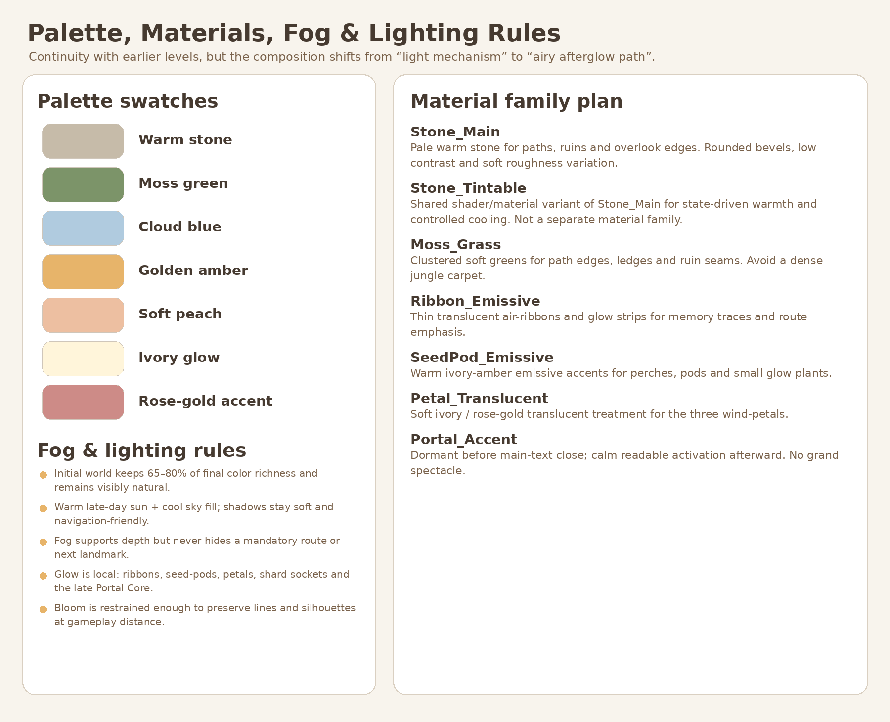
Figure 4. Approved palette/material direction from Visual Master v1.1. Text and tables in this Bible remain production authority.
Family | Layer | Maps | Production rule
M_L03_Stone_Warm | BASE/STRUCT | BaseColor, Normal, Roughness, optional AO | Primary warm ancient stone; matte, low-noise, no baked final lighting.
M_L03_Stone_Tintable | BASE/STRUCT shared shader variant | Same maps + controlled tint/saturation parameters | Variant of Stone_Warm, not a separate texture family. Supports E0–E5 without shared-resource mutation.
M_L03_Soil_Path | BASE | BaseColor, Normal, Roughness, optional AO | Soft route/soil transition; avoids hard tiled path edges.
M_L03_Moss_Grass | BASE/DECOR | BaseColor, Normal, Roughness, optional AO | Moss and low grass; shared atlas/tiling preferred.
M_L03_Bark_Root | DECOR | BaseColor, Normal, Roughness | Trees and root clusters; muted, not dark-horror bark.
M_L03_Foliage_Atlas | DECOR | BaseColor+alpha, Normal optional, Roughness | Shared trees/bush/grass/flowers. Avoid complex transparency on large surfaces.
M_L03_WindRibbon_Emissive | STRUCT/VFX | BaseColor or gradient + emission mask | Warm amber/ivory, separable and controllable; must remain readable without heavy bloom.
M_L03_SeedPod_Emissive | STRUCT/DECOR/VFX | BaseColor + emission mask | Warm impulse/perch family. No face/eyes/mascot appearance.
M_L03_Petal_Translucent | STRUCT/VFX | BaseColor, Normal optional, Roughness, emission mask | Soft ivory/peach/rose-gold; restrained transparency.
M_L03_RestPoint_Emissive | STRUCT/VFX | BaseColor + emission mask | Three readable segments; display-only, no state ownership.
M_L03_Distant_Silhouette | BACKGROUND | BaseColor/Roughness minimal | Low-frequency distant layers compatible with haze.
M_L03_PortalAccent | VFX only | Emission/gradient as needed | Level-local accent only. Shared LevelPortal keeps its own materials and activation state.

7.1 Environment-state compatibility
Phase | Art requirement
E0 Initial | Natural stone/green/cloud-blue visible; richness approx. 65–80% of final. No grayscale/dead material variants.
E1 After Shard_05 | Tintable stone/grass/ribbons support a 4–5 s non-blocking clarity increase.
E2 After Shard_06 | Warm motes and clearer midground without global flash or material swap.
E3 / E4 Meadow progress | Local haze and Rest Point segment changes remain independently controllable.
E5 After Shard_07 / Synthesis | Full warm state and converging motifs; portal remains dormant.
E6 After main text | Only local calm portal accent plus shared LevelPortal activation. No grand spectacle.

8. Production sheets

8.1 BASE blocks and route kit
• Each zone is an independently swappable block wrapper. Authoritative zone coordinates do not move. Non-authoritative dressing may shift by at most ±1.5 m only when all locked route, puzzle, portal, camera and seam constraints remain unchanged.
• Route seams are explicit and documented. Walkable collision continuity is validated before any decor pass.
• Visible edge modules and the hard StaticBody boundary belt are separate. Visible rims belong to STRUCT/DECOR; the authoritative hard belt belongs to EnvironmentRoot/BoundaryRoot or an approved block-local collision root under EnvironmentRoot.
• Underside trim is visual only and never becomes a catch floor across empty space.
Block | Art composition | Required protected spaces
Quiet Inlet | Low shelf, gentle framing tree/ruin, first arch silhouette, open long view | Spawn, 5.5 m route, CP0 sightline, RA0 clearance
Wind Trace Route | Three arch placements, light grass response patches, restrained cliff edges | 6.5 m arch openings, 5.2 m overhead, continuous walkable floor
Shard05 Overlook | Small open pause with low edge composition | Shard 3 m radius, >=2.5 m edge distance, preview to glade
Playful Glade | Oval, asymmetrical low ruin/seed-pod frame | All three perch clearances and one camera composition
Connector | Reduced prop density and cleaner horizon | 5.5–6 m route, no false target
Breathing Meadow | Broad open center, 3 petal compositions, low perimeter | All petals visible from entry; 3 m clear radii; Rest Point center
Final Overlook | Modular horizon frame and dormant portal setting | Main gate R4.5, portal R4.5, horizon and CP4 line

8.2 Wind_Arch_Family production sheet
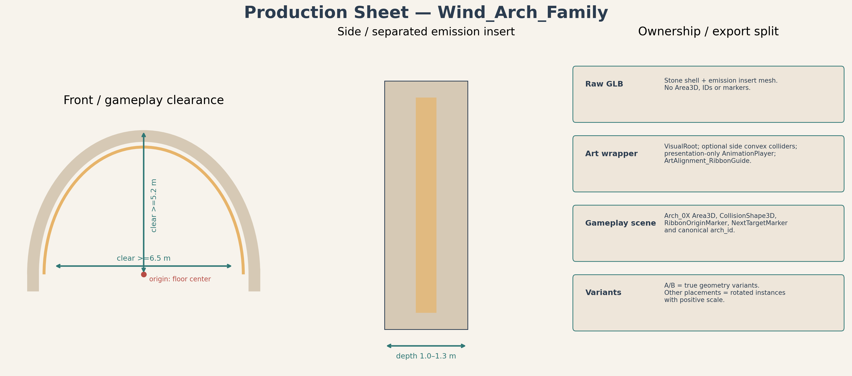
Figure 5. Wind Arch decomposition, origin, clear opening and ownership split.
• Frame and emission insert export separately or as clearly separated mesh objects/material slots.
• Mesh origin is floor-center between supports. Gameplay crossing Area3D and IDs remain external.
• Authoritative RibbonOrigin and NextTarget markers remain in WindTrace gameplay scene. Art may provide only ArtAlignment_Ribbon guidance.
• Support collision is optional and simple; it cannot reduce the 6.5 m clear width or 5.2 m overhead clearance.
• A and B are explicit positive-scale variants. Do not use negative-scale mirroring.

8.3 SeedPod_Perch_Family and Playful Spark production sheet
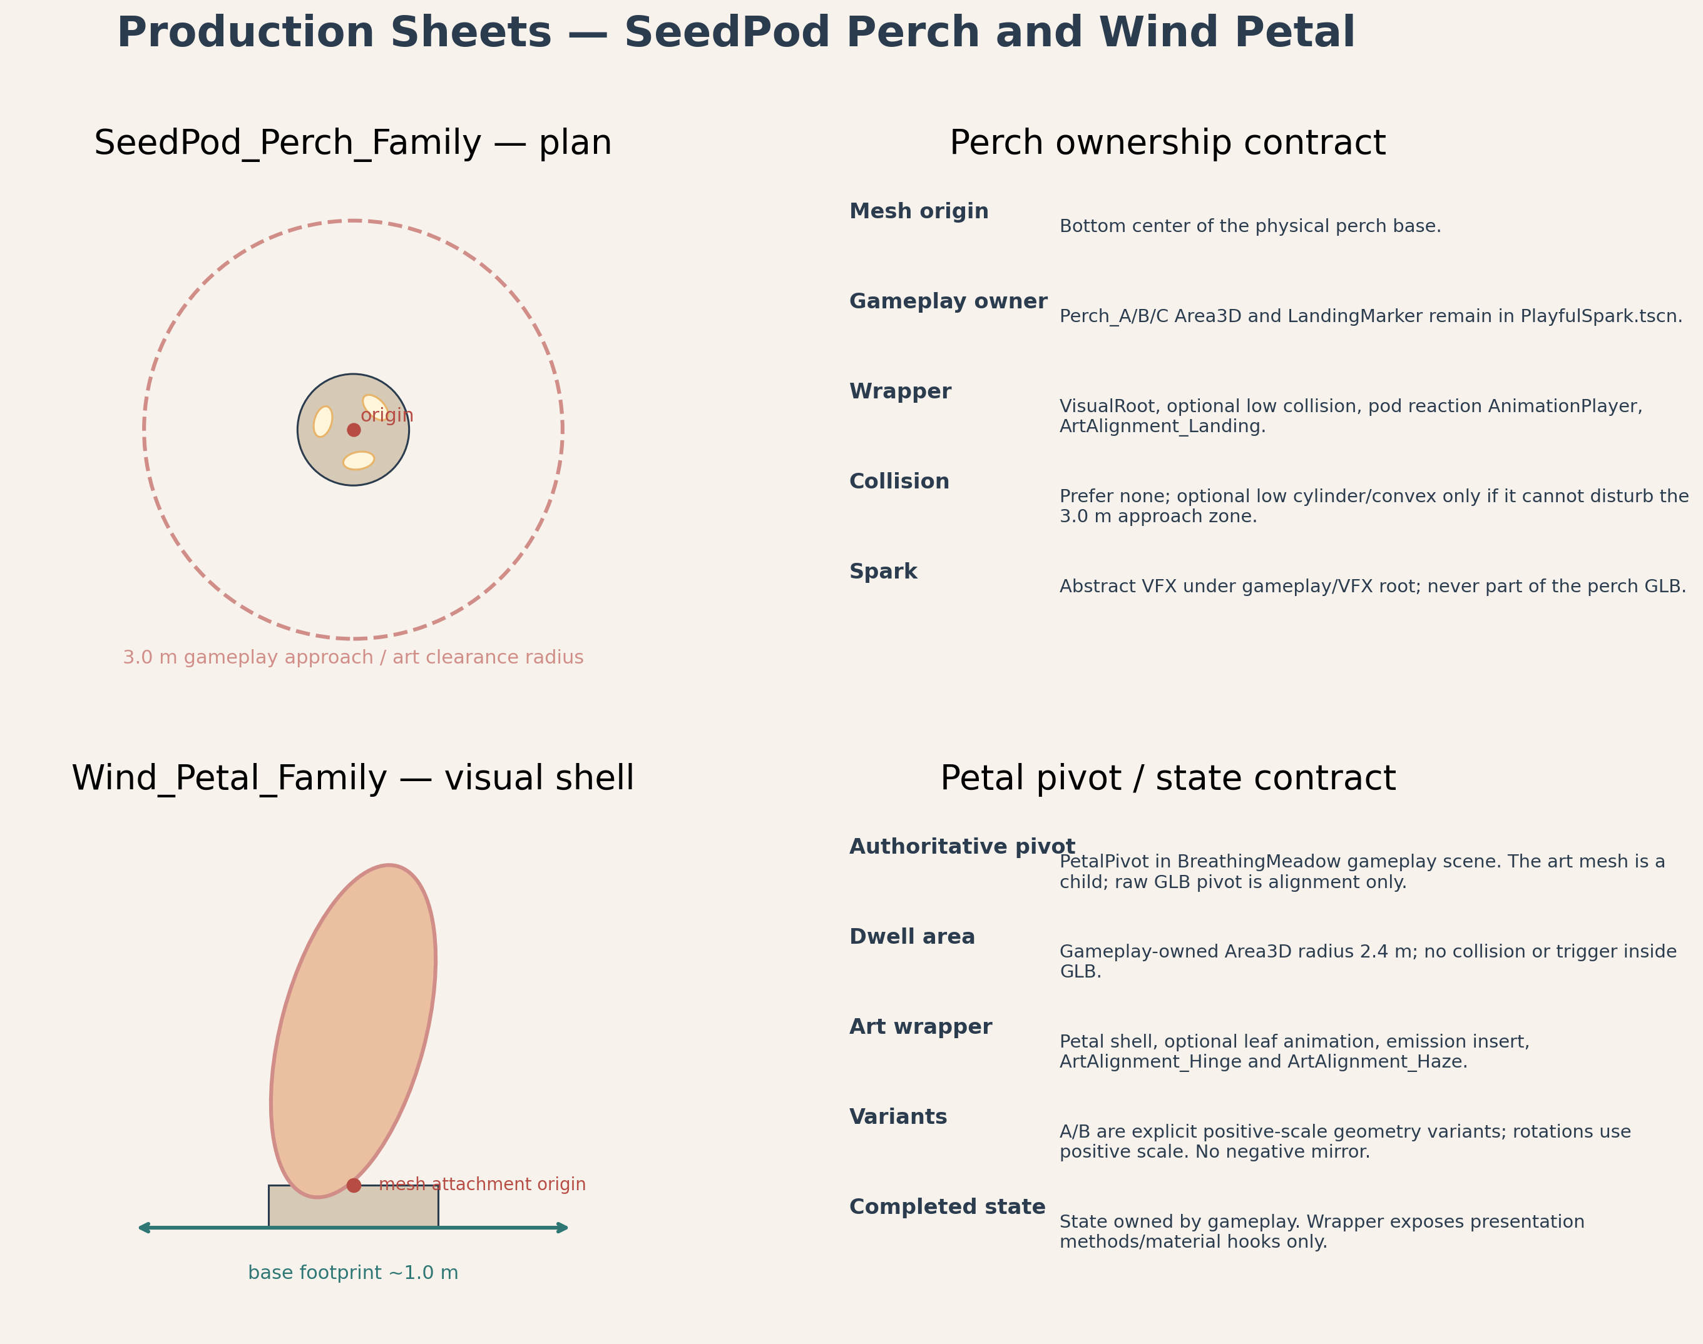
Figure 6. Perch and wind-petal visual decomposition with gameplay-owned landing/pivot contracts.
Component | Art responsibility | Gameplay authority retained outside art
Perch base | Readable low landing/reaction support and optional simple static collision | Approach Area3D, current sequence ID, LandingMarker and occupancy semantics
Seed-pod cluster | Warm reaction/opening presentation; separable emissive parts if practical | Sequence completion, preglow timing and Shard_06 reveal
Spark impulse VFX | Abstract warm light point/trail with no face, eyes, wings or mascot behavior | A→B→C ordering, hop terminal/fallback and destination selection

8.4 Wind_Petal_Family and Rest Point production sheet
Component | Production contract
Petal base | Static visual socket centered at the gameplay target. No dwell Area3D in GLB.
Petal leaf | Independent mesh with attachment-point origin. Gameplay-owned PetalPivot controls any presentation transform.
Variants | L03_WindPetal_Leaf_A and L03_WindPetal_Leaf_B are separate explicit positive-scale assets. Three placed instances may rotate; negative scale is forbidden.
Rest Point dais | Low center composition, Ø3.2 m target. Does not become a shrine or raised altar.
Progress segments | Three identical or explicit arc inserts; display-only, independently addressable by wrapper/material, state owned by gameplay.
Haze binding | No fog volume inside GLB. EnvironmentStateRoot owns LocalHaze_W/SE/NE.

8.5 Final Overlook composition sheet
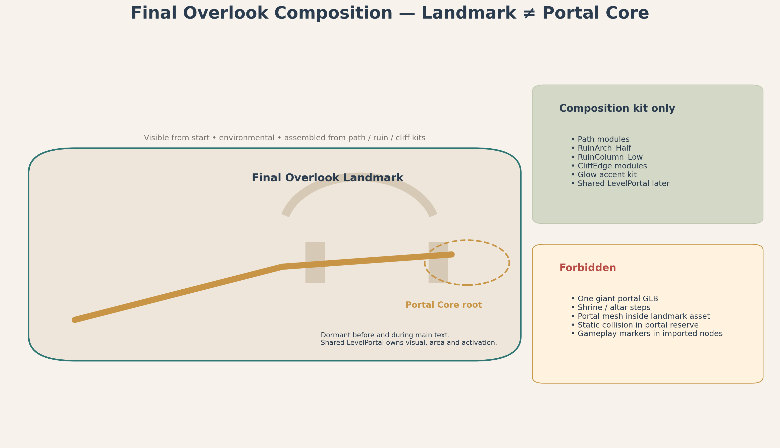
Figure 7. Final Overlook is a modular environmental landmark. Portal Core remains a separate shared gameplay-owned scene.
• Final Overlook Landmark is visible from the beginning as the clearest distant silhouette. It is not an active portal frame.
• The composition uses path, ruin, cliff-edge and glow-accent kits. It is not a new hero asset family and does not require a monolithic GLB.
• LevelPortalRoot / PortalFloorAnchor at (10.0, 1.6, 50.5) remains authoritative and external to all art GLBs.
• The shared LevelPortal footprint stays clear. Level_03 local PortalAccentVFX begins only after main text and never fabricates shared activation state.
• The horizon remains open. No altar stair, shrine axis, trophy pedestal or giant destination portal.

9. Collision matrix
Element | Owner | Recommended collision | Required? | Acceptance rule
Walkable zone blocks | StaticBody3D under EnvironmentRoot/BaseGeometry or approved block-local collision root under EnvironmentRoot | Simplified custom floor proxy | Required | Matches approved floor; no holes >0.10 m; cross-slope <=3°.
Path modules | StaticBody3D | Simple custom/box blend | Required | Continuous seams; step <=0.15 m; slope limits preserved.
Hard boundary belt | StaticBody3D under EnvironmentRoot/BoundaryRoot or approved block-local collision root under EnvironmentRoot | Godot boxes/convex strips following approved edge; not raw GLB-owned | Required | Behind visible rim; no route-mouth obstruction; no reduction of route/puzzle/portal/camera clearances.
Visible cliff/edge art | Art wrapper | Usually none | Optional | Never relied on as sole fall prevention.
Wind arch supports | Art wrapper | Simple convex per support | Optional | No central collision; clear W/H maintained.
Perch base | Art wrapper | Low convex or none | Optional | Cannot impede 3 m approach clearance.
Seed-pods | Art wrapper | None | No | Presentation only.
Wind petal leaf/base | Art wrapper | None or tiny static base only | Prefer none | Dwell Area3D and pivot remain gameplay-owned.
Rest Point dais | Art wrapper | Low cylinder/custom | Optional | No raised step >0.15 m.
Ruin modules | Art wrapper | Simple box/convex if player-facing | Selective | Avoid complex mesh collision.
Major tree trunk | Art wrapper | Simple capsule/box | Selective | Only outside camera corridor and puzzle clearances.
Small foliage/debris | Art wrapper | None | No | Must not block route.
SoftReturn / OOB | GameplayRoot/SafetyRoot | Area3D volumes | Required | Recovery Area3D only. No physical catch collision and no overlap with legal side spaces or overlooks.
Portal | Shared LevelPortal | Shared InteractionArea/shape | Required / shared | No custom duplicate collision or trigger.
Moving/presentation meshes | VFX/art wrapper | None | No | No trimesh moving collision.

10. Pivot, origin and marker contracts
Asset type | Raw mesh origin | Purpose | Authoritative gameplay counterpart
Static block base | Zone center on authored floor plane | Placement and art swap | World zone coordinates / block wrapper owns placement
Path straight/curve/ramp | Documented seam center; tangent/forward recorded | Seam assembly | Gameplay centerline remains external authority
Cliff/edge module | Inner top seam center | Align visible rim | Hard boundary collision external
Wind arch frame | Floor-center between supports; local authored forward -Y in Blender | Placement and positive-scale rotation | Arch crossing Area3D, RibbonOrigin and NextTarget external
Perch base / seed-pod | Bottom-center at support contact | Presentation placement | LandingMarker and approach Area3D external
Wind petal leaf | Physical attachment point at petal root | Visual drift/open animation | Authoritative PetalPivot external
Rest Point dais | Center on ground | Composition placement | ConvergenceMarker and progress facts external
Shard platform | Center on ground beneath shard | Visual support | ShardAnchor external
Ruin / tree | Bottom-center or documented seam | Placement / modular assembly | No gameplay target embedded
Final Overlook composition | Wrapper origin at (6,1.6,47) composition center | Assemble modular kit | Main_Text_Gate and LevelPortalRoot external

Marker naming
Art wrappers may expose non-authoritative alignment aids only, prefixed ArtAlignment_. Examples: ArtAlignment_Ribbon, ArtAlignment_SeedPodAttach and ArtAlignment_PetalAttach. Gameplay scenes do not bind progression to imported GLB child names.

10.1 SoulOrb_Follow production decision
Concern | Locked decision
Asset decision | REUSE the shared SoulOrb_Follow asset. Do not create a Level_03-specific orb model, GLB, wrapper or material family.
Semi-hero budget | SoulOrb_Follow is not a fourth semi-hero family and is excluded from the Level_03 asset registry.
Level_03 parent transform | No Level_03-specific override: location 0/0/0, rotation 0/0/0, scale 1/1/1 on the shared instance parent. The shared scene keeps its own internal follow offset.
Technical ownership | target_path and orientation_source_path remain exactly as locked by Technical Architecture; art does not redefine them.
Art clearance | Environment art must preserve Player movement, third-person camera and recovery-anchor clearance. No arch, foliage, ruin or overhang may clip the orb along the accepted traversal/camera envelope.

11. Wrapper-first Blender → GLB → Godot pipeline
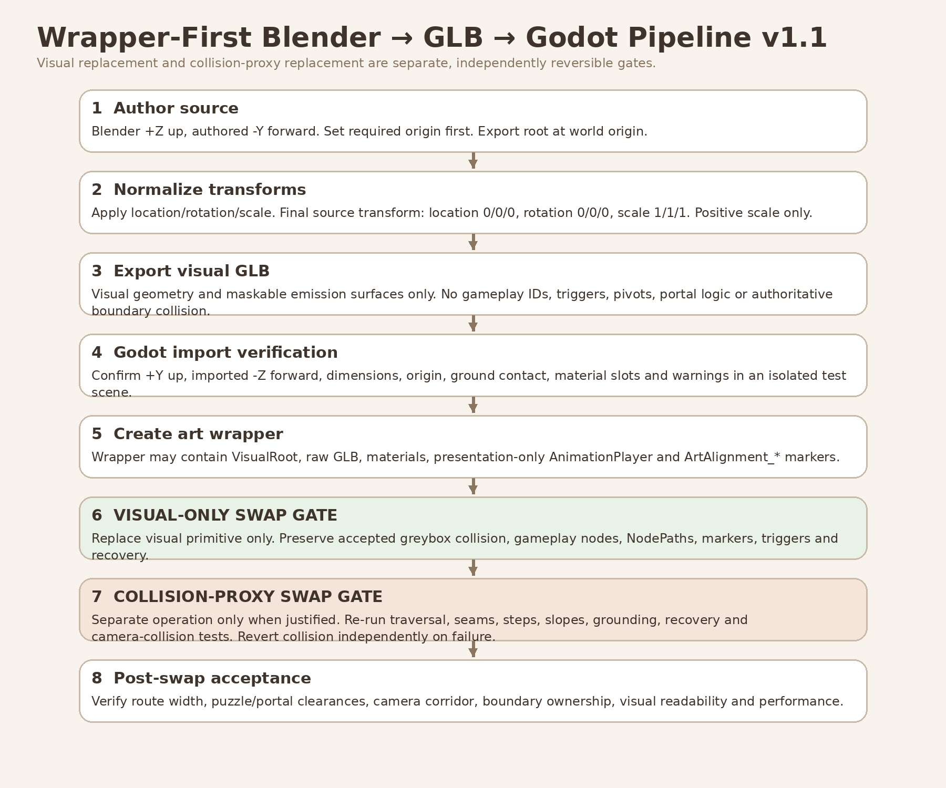
Figure 8. Wrapper-first pipeline v1.1. Visual-only replacement and collision-proxy replacement are separate, independently reversible gates.
1. Author in Blender: Model one canonical asset family/component at metric scale. Keep material slots minimal and separate any maskable emission surface.
2. Validate source: Apply transforms; confirm +Z up, authored -Y forward, positive scale, documented origin and no hidden/unused production objects.
3. Export raw GLB: Use standard glTF 2.0. Export visual mesh only plus optional explicit _COL asset when a custom collision proxy is justified.
4. Godot import test: Open in an isolated import verification scene. Confirm scale, +Y up/-Z forward result, origin, ground contact, slots and warnings.
5. Create art wrapper: Wrapper contains VisualRoot, raw GLB instance, approved static collision, optional presentation-only AnimationPlayer and ArtAlignment_* markers.
6. Integrate into block/gameplay parent: Parent scene owns placement and all gameplay references. Wrapper remains replaceable and receives presentation calls only.
7. Visual-only swap gate: replace only the visual primitive or VisualRoot child. Preserve the Producer-accepted greybox collision, all gameplay Area3D nodes, authoritative pivots/markers, IDs, NodePaths, portal root and recovery nodes.
8. Collision-proxy swap gate: perform as a separate post-greybox operation only when justified. Re-run traversal, seams, step height, slope, grounding, recovery and camera-collision tests. If any test fails, revert collision independently while keeping the accepted visual swap.
9. Acceptance regression: after each visual or collision operation, re-run route width, clearances, camera QA, puzzle readability, boundary ownership, missing-VFX fallback and performance checks.

11.1 Wrapper content contract
Wrapper may contain | Wrapper must not contain
Raw GLB visual instance | Canonical gameplay ID, puzzle order or authoritative hard boundary belt
Approved block-local StaticBody3D/CollisionShape3D for walkable geometry after the separate collision-proxy gate | Area3D interaction/dwell/crossing triggers
Material overrides / scene-local duplicated materials | Shard spawn/reveal ownership
Presentation-only AnimationPlayer | Authoritative RotationPivot / PetalPivot / LandingMarker / Beam targets
ArtAlignment_* markers | Level progression, reward, portal or recovery scripts
Visibility / LOD / culling configuration | Critical NodePaths into imported child hierarchy

12. IMMEDIATE GREYBOX HANDOFF
AUTHORIZED CONTENT OF A FUTURE GREYBOX DEVELOPMENT REFERENCE
Only dimensions, coordinates, proxy shapes, collision policy, layer boundaries, gameplay-owned pivot/marker contracts and acceptance criteria from this Bible may flow into the future Greybox Development Reference. This Bible itself does not authorize implementation.

May be consumed immediately after Producer approval | Must remain deferred
P00–P16 route coordinates and all locked gameplay anchors | Final Blender models and GLBs
Zone footprints, floor elevations, route widths and slopes | Final textures and material authoring
Primitive platform/path/blocker shapes | Godot art wrappers for production meshes
Hard boundary belt, SoftReturn/OOB policy and RA0–RA6 anchors | Final foliage, ruin dressing and background silhouettes
Arch/perch/petal proxy dimensions and 3 m clearances | Polished ribbon/spark/petal/haze VFX
Gameplay-owned pivot/marker placeholders and VisualMount nodes | Final environment lighting/color polish
Portal clearance and shared LevelPortal root anchor | Final portal accent or custom portal visuals
Camera QA points CP0–CP4 and sightline gates | Optimization based on unapproved art content

12.1 Greybox acceptance preconditions before art swap
• Full route traversable with no mandatory jump, gap or abrupt step; floor profile matches the approved spec.
• Minimum route, shoulder, camera and puzzle clearances pass at all beats.
• All three arches, perches and petals are readable with primitive proxies and approved third-person camera.
• Hard boundaries and explicit SoftReturn/OOB recovery pass without invisible playable space.
• Shard reward, main-text and shared portal flows pass with primitives and optional VFX disabled.
• All gameplay pivots, markers and triggers live outside art placeholders and remain stable under a dummy visual swap.
• Producer explicitly accepts the greybox before post-greybox art integration begins.

13. POST-GREYBOX ART INTEGRATION SLICES
DO NOT EXECUTE THESE SLICES IN THE INITIAL LEVEL_03 GREYBOX PR.
Each slice begins only after the greybox acceptance gate and should remain small, reviewable and independently reversible.

Slice | Scope | Exit gate
A. Import foundation | Create approved folder structure, import-test scene and wrapper template; document baseline warnings. | One sample asset imports at correct scale/origin; no gameplay tree changes.
B. BASE visual swap | Replace visual primitives / VisualRoot content one block at a time while preserving accepted greybox collision. | Visual regression passes; route, camera and gameplay nodes unchanged.
C. Wind Arch family | Produce L03_WindArch_Frame_A, L03_WindArch_Frame_B and their exact EmissionInsert_A / EmissionInsert_B assets; integrate without moving gameplay triggers. | Three arches retain clear W/H, IDs and hint behavior.
D. SeedPod/Perch family | Produce perch bases, pod clusters and restrained impulse VFX. | A→B→C sequence remains readable; no mascot reading.
E. Wind Petal / Rest Point | Produce petal base/leaf variants, dais and segments. | All targets visible; proximity dwell and all six orders pass.
F. Ruin/cliff/overlook composition | Build modular ruin/cliff kit and assemble Final Overlook landmark. | No shrine/arena reading; portal footprint and horizon stay clear.
G. DECOR pass | Trees, rocks, roots, grass, flowers, vines and distant silhouettes. | Route/camera/puzzle exclusion zones remain clean.
H. Material/state integration | Author shared families and scene-local tintable instances for E0–E6. | No shared-resource mutation; E0 color visibly alive.
I. VFX integration | Ribbons, grass response, spark, petal preglow, local haze, synthesis and portal accent. | Presentation removal cannot block progression; fallbacks pass.
J. Optimization and acceptance | LOD/culling, collision simplification, import warnings, visual QA and performance evidence. | All art gates and 60 FPS target evidence pass on agreed baseline.
B2. Optional collision-proxy swap | Only after a visual swap passes and only when justified; replace one collision proxy independently. | Traversal, seams, steps, slopes, grounding, recovery and camera-collision pass; collision can be reverted independently.

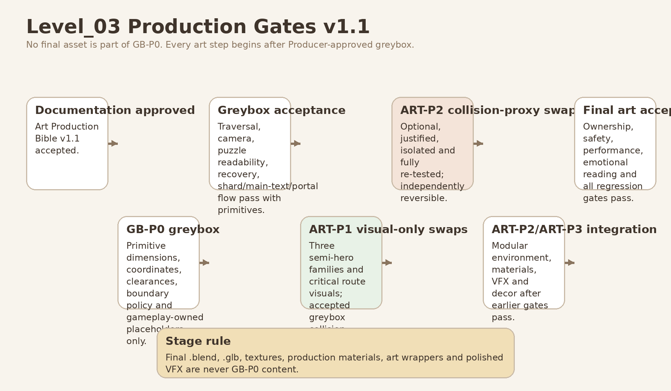
Figure 9. Production gates v1.1. GB-P0 contains primitives and contracts only; visual and collision art swaps are separate post-greybox gates.

14. Production priority
Stage priority | Content | Reason
GB-P0 - proxy input only | Zone dimensions, route proxies, boundary-belt primitives, SoftReturn/OOB, clearances, portal floor anchor and gameplay-owned pivot/marker placeholders. | No final .blend, .glb, texture, production material, art wrapper or polished VFX is GB-P0 content.
ART-P1 - post-greybox readability | Wind_Arch_Family, SeedPod_Perch_Family, Wind_Petal_Family, shard support and minimal readability VFX. | Begins only after Producer-approved greybox; visual-only swap first.
ART-P2 - post-greybox identity | BASE visual blocks, ruin/cliff kits, Final Overlook modular composition, Rest Point composition, material/state integration and key VFX. | Collision-proxy swaps are separate optional operations with full regression.
ART-P3 - post-greybox polish | Bushes, grass, flowers, vines, moss, debris, ambient seed-pods, distant silhouettes and secondary VFX. | Removable polish; never blocks readability or shipping.

15. Blender / GLB / Godot export checklist
☐ 1 BU = 1 m; +Z up; authored -Y forward documented.
☐ Required origin set first; exported root placed at world origin; transforms applied; final location 0/0/0, rotation 0/0/0, scale 1/1/1; all instances remain positive scale.
☐ Origin matches the registry contract and ground contact is correct.
☐ No hidden unused objects, duplicate meshes, cameras or lights unless explicitly required.
☐ No unapplied modifier that changes export unexpectedly.
☐ Minimal material slots; emission surfaces separate or maskable where required.
☐ No gameplay script, canonical ID, Area3D, target or state inside raw GLB.
☐ Optional custom collision is a separate simple proxy and never a moving trimesh.
☐ File and object naming follows L03_* rules; explicit variant suffix is unambiguous.
☐ GLB test-imported in Godot; +Y up / -Z forward result, size, materials and warnings verified.
☐ Wrapper scene created only in post-greybox slice; VisualRoot and collision ownership documented.
☐ No negative-scale instance in Blender export or Godot placement.
☐ ArtAlignment_* markers are non-authoritative and optional.
☐ Visual-only swap leaves accepted greybox collision, gameplay pivots, Area3D nodes, IDs, NodePaths, LevelPortalRoot and recovery ownership untouched.
☐ Any collision-proxy swap is a separate operation with traversal, seam, step, slope, grounding, recovery and camera-collision evidence, plus independent collision rollback proof.
☐ QA evidence captures route clearance, camera sightlines, puzzle readability and missing-VFX behavior.

16. Art acceptance gates
Gate | Acceptance criterion
A-01 Scale / coordinates | Gameplay anchors, triggers, Area3D nodes, pivots, LevelPortalRoot, recovery anchors and NodePaths move 0.00 m. Non-authoritative dressing may shift only within ±1.5 m and may not reduce any locked clearance. Block seams remain <=0.10 m.
A-02 Traversal | Route never falls below 5.5 m; turns/rewards remain 6–7 m; no mandatory gap/step/jump introduced.
A-03 Camera safety | 8.5 m camera corridor and CP0–CP4 sightlines remain clear; no near-camera foliage wall or tall prop pop-in.
A-04 Puzzle clearance | 3 m clear radius around shards, perches, petals and rest point; all required targets readable from zone entry.
A-05 Boundary integrity | Hard StaticBody belt remains under EnvironmentRoot/BoundaryRoot or approved block-local collision root under EnvironmentRoot, behind the STRUCT/DECOR visible rim. SafetyRoot owns only recovery volumes/markers. All route mouths remain open; no invisible catch floor or legal-space recovery overlap.
A-06 Ownership | No gameplay state, canonical ID, authoritative marker/pivot, trigger or portal logic inside GLB/art wrapper.
A-07 Silhouette / emotion | Continuous airy S-walk; no hub, arena, shrine, fortress, trophy or dead-world reading.
A-08 Family budget | Only three semi-hero families. Final Overlook and Rest Point are modular compositions.
A-09 Materials | Shared families, no 4K by default, no excessive unique slots, E0 visibly colored and alive.
A-10 Environment phases | E0–E6 visual targets remain non-blocking and local; portal inactive through synthesis/main text.
A-11 VFX compatibility | All presentation nodes removable/disabled without softlock; no over-bloom or audio dependency.
A-12 Import stability | No import errors, invalid resources or fragile child-name dependencies; positive scale everywhere.
A-13 Performance | Agreed 60 FPS target holds on the project baseline after LOD/culling and effects pass.
A-14 Regression | Shard rewards, fall recovery, main text and Level_04 transition still pass after every art swap.
A-15 Collision-swap isolation | Visual-only swaps preserve accepted greybox collision. Any custom collision-proxy swap is separately approved, fully regressed and independently reversible without removing the accepted visual asset.

17. Production risks and corrections
Risk | Severity | Mitigation
R-01 Monolithic environment GLB | High | Block-level wrappers and modular families; forbid one giant Level_03 export.
R-02 Art moves gameplay anchors | High | All authoritative markers remain in gameplay scenes; visual swap test required.
R-03 Negative-scale variants | High | Explicit Blender variants with applied mirror; positive-scale instance audit.
R-04 Boundary art creates invisible wall mismatch | High | Visible STRUCT/DECOR rim and EnvironmentRoot-owned hard belt are reviewed together; route openings and camera corridor tested from both directions.
R-05 Decorative clutter hides route or targets | High | Enforce shoulder/camera/puzzle exclusion zones before dressing approval.
R-06 Final Overlook reads as shrine/portal from start | High | Modular environmental silhouette; portal core dormant and visually secondary until main-text close.
R-07 Spark becomes mascot | Medium | Abstract light impulse only; no face, eyes, wings, voice or character poses.
R-08 Materials require unique texture set per asset | Medium | Shared tiling/atlas families; approve exceptions explicitly.
R-09 Environment tween mutates shared material resources | High | Scene-local/deeply duplicated runtime resources; wrapper materials prepared for local override.
R-10 Collision complexity harms movement/performance | High | Simplified custom proxies; no moving trimesh; collision matrix gate.
R-11 Final art enters greybox PR | High | Immediate/deferred gate and explicit post-greybox slice labels.
R-12 VFX softlocks progress | High | VFX owns no progression; controller bounded fallbacks remain authoritative.
R-13 Visual and collision swapped together | High | Use two independent gates. Preserve greybox collision for visual approval; collision proxy receives its own tests and rollback.

18. Handoff boundary
Consumer | Receives from this Bible | Must not infer
Producer | Scope, family budget, production gates, art risks and acceptance criteria | That implementation or final art is authorized.
Greybox Development Reference author | Coordinates, dimensions, proxy shapes, boundary/collision rules, pivot contracts and immediate handoff list | Final meshes, materials, wrappers or post-greybox slices in the initial PR.
Godot Tech | Ownership boundaries, wrapper contracts, collision/pivot rules and art-swap requirements | Any replacement of Technical Architecture NodePaths/state contracts.
Blender / Art | Full registry, dimensions, origins, variants, materials, budgets, paths and export checklist | Gameplay state or target ownership inside GLB.
Codex Task Generator | Only post-approval, stage-appropriate slices; immediate greybox vs deferred art split | A single giant implementation task or cross-stage PR.
QA | Boundary, camera, readability, import, performance and regression gates | That concept images define exact geometry.

Appendix A. Exact production anchors and camera/recovery references
Identity | Vector3 / dimensions | Authority
P00 Spawn centerline | (-6.00, 0.00, -49.00) | Route / block
P01 Inlet exit | (-5.80, 0.08, -43.00) | Route
P02 Arch_01 | (-5.50, 0.15, -40.50) | Route / gameplay
P03 Curve east | (1.00, 0.35, -35.00) | Route
P04 Arch_02 | (2.00, 0.45, -32.00) | Route / gameplay
P05 Curve west | (-1.00, 0.65, -27.00) | Route
P06 Arch_03 | (-3.50, 0.80, -23.50) | Route / gameplay
P07 Shard05 overlook | (-8.00, 0.90, -16.00) | Route / block
P08 Glade approach | (-1.00, 0.95, -9.00) | Route
P09 Playful Glade center | (7.00, 1.00, -3.00) | Route / block
P10 Glade exit | (4.00, 1.05, 7.00) | Route
P11 Exhale bend | (-1.00, 1.15, 13.00) | Route
P12 Meadow entry | (-4.00, 1.28, 18.00) | Route
P13 Meadow center | (-7.00, 1.30, 28.50) | Route / block
P14 Final approach | (-1.50, 1.45, 38.00) | Route
P15 Final Overlook | (6.00, 1.60, 47.00) | Route / block
P16 LevelPortalRoot | (10.00, 1.60, 50.50) | Shared portal floor anchor
Shard_05 | (-8.00, 2.00, -15.00) | Gameplay anchor
Perch_A | (1.50, 1.05, -7.00) | Gameplay anchor
Perch_B | (10.50, 1.05, -3.00) | Gameplay anchor
Perch_C | (4.00, 1.05, 3.00) | Gameplay anchor
Shard_06 | (4.00, 2.00, 4.20) | Gameplay anchor
Petal_W | (-16.00, 1.30, 27.00) | Gameplay anchor
Petal_SE | (-4.00, 1.30, 21.50) | Gameplay anchor
Petal_NE | (-1.50, 1.35, 34.00) | Gameplay anchor
Rest_Point / Shard_07 | (-7.00, 1.30 / 2.20, 28.50) | Gameplay anchor
Main_Text_Gate | (6.00, 1.60, 47.00), R4.5 | Gameplay gate

Appendix B. Camera QA and recovery anchors
Reference | Position / target | Art/QA rule
CP0 Arrival | (-9,5.5,-44) → look at (6,2.5,47) | Final Overlook silhouette readable; portal not dominant
CP1 Shard05 | (-10,5,-18) → look at (7,1,-3) | Playful Glade preview
CP2 Glade | (1,6,-9) → look at (7,1,-3) | All three perches in one composition
CP3 Meadow | (-3,7,18) → look at (-7,1.3,28.5) | All three petals and Rest Point readable
CP4 Final | (0,6,41) → look at (6,1.6,47) | Final landmark/horizon and dormant portal floor setting
RA0 | (-6,.65,-49) | Guaranteed fallback
RA1 | (-4.5,.95,-20) | Wind Trace milestone
RA2 | (-8,1,-16) | Shard05 overlook
RA3 | (4,1.1,7) | Glade exit
RA4 | (-4,1.35,18) | Meadow entry
RA5 | (-7,1.4,28.5) | Meadow center
RA6 | (6,1.7,46) | Final approach

Appendix C. Visual authority references
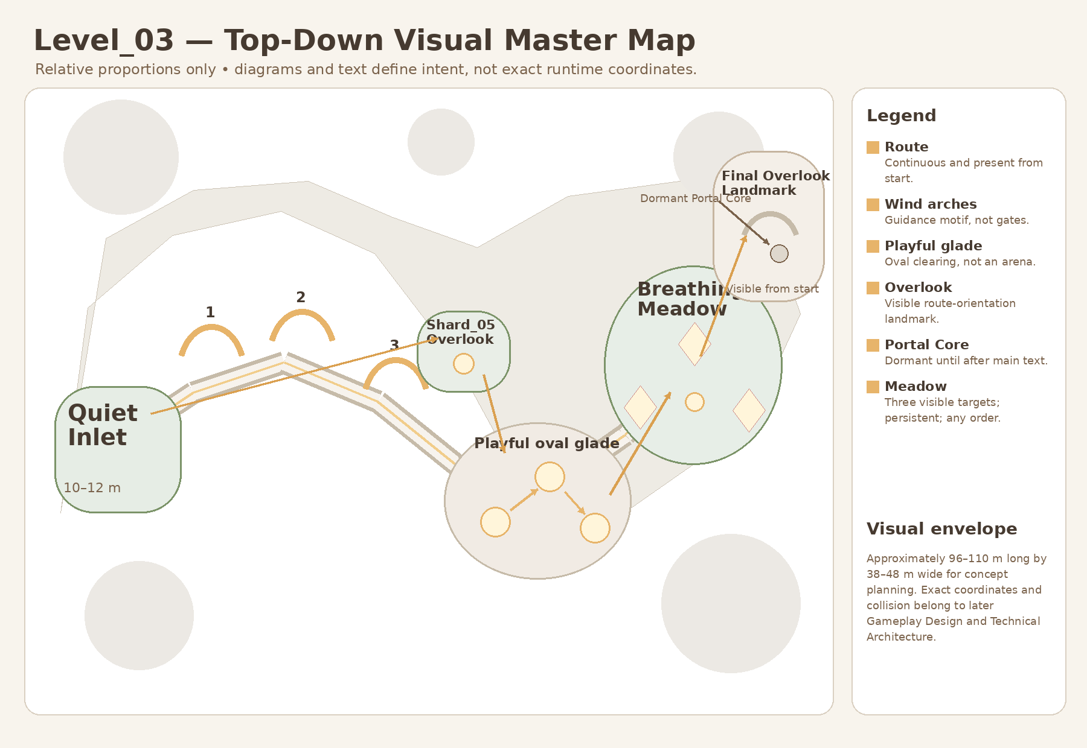
Approved Level_03 top-down visual reference. The exact Gameplay Spec coordinates and Boundary Map in this Bible take precedence for production geometry.
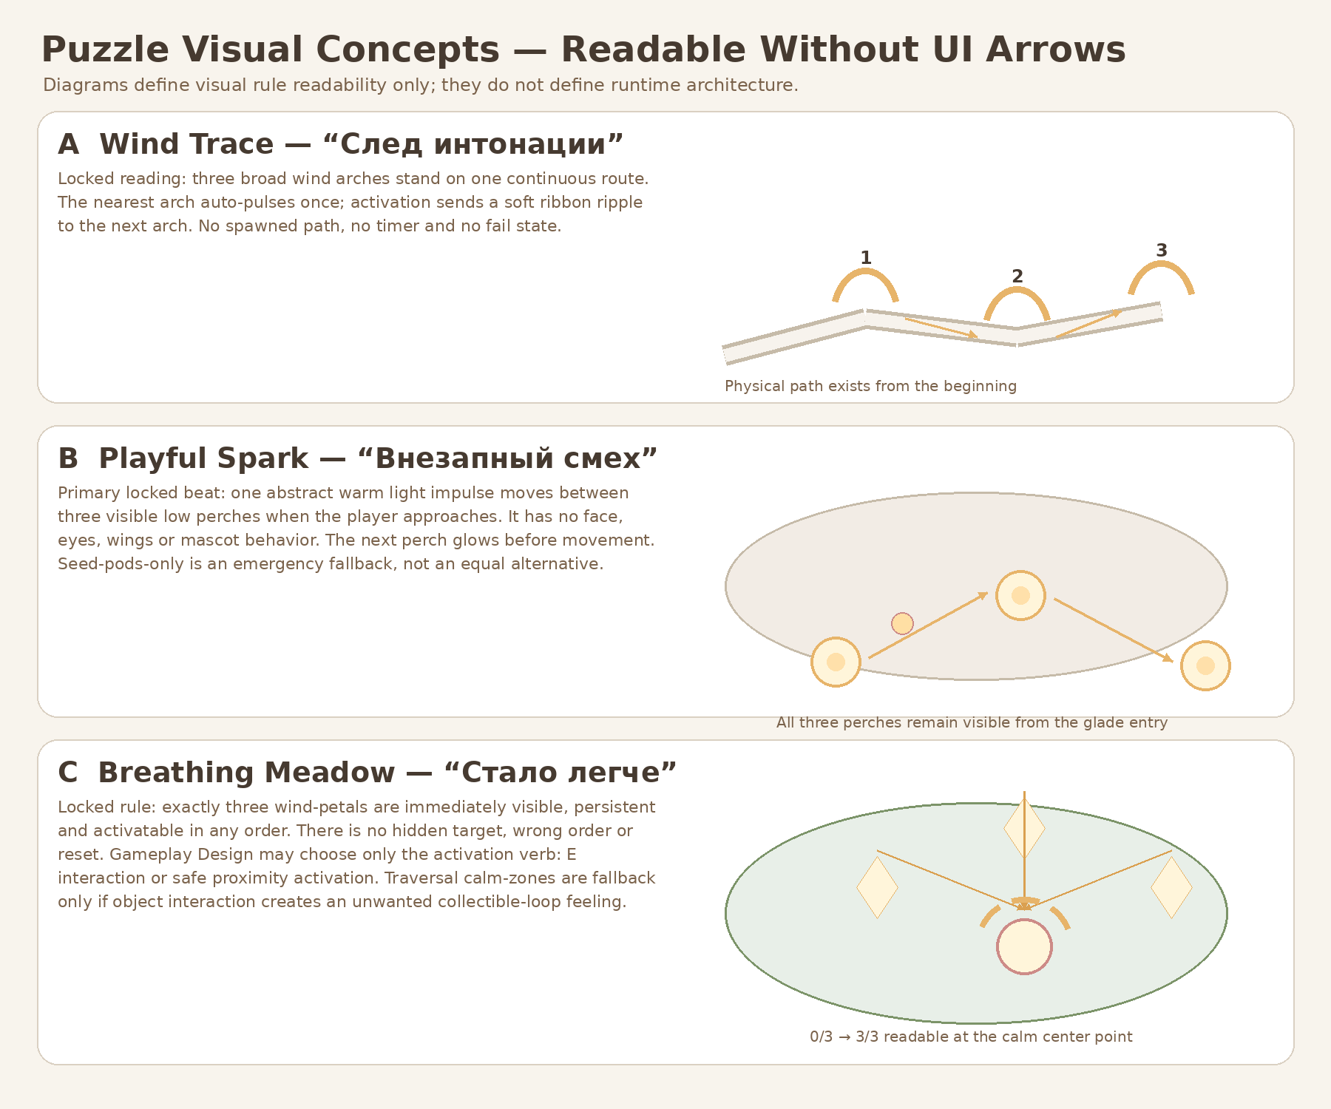
Approved puzzle-readability reference. Production sheets and gameplay-owned marker contracts in this Bible define the integration boundary.
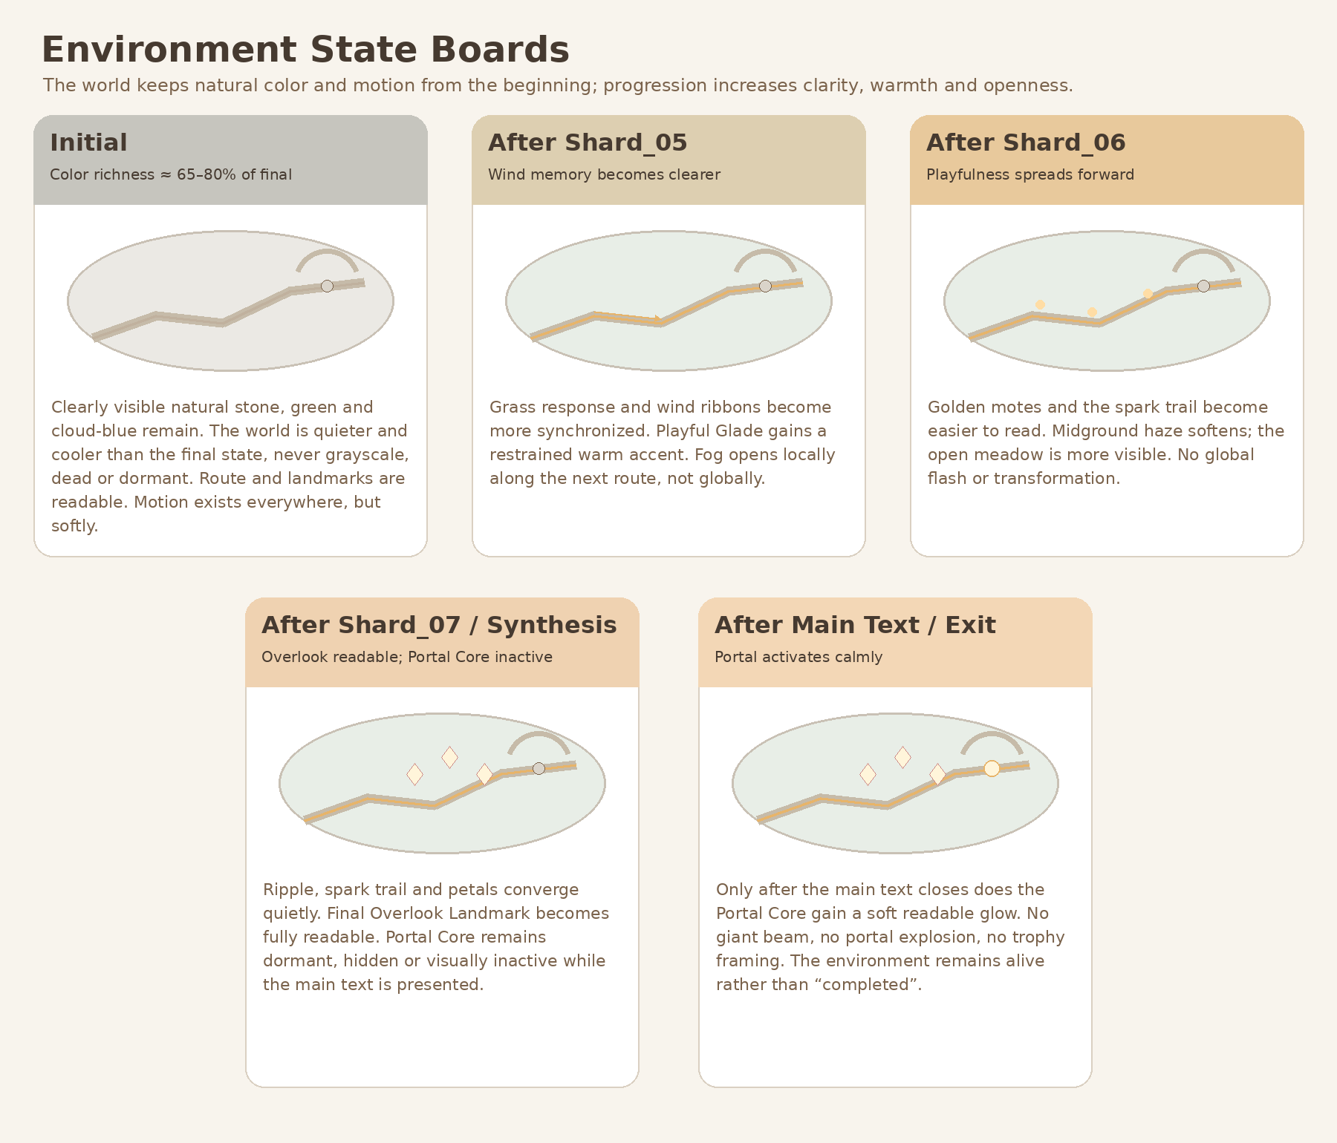
Approved environment-state reference. Materials and VFX must support these states without owning progression.
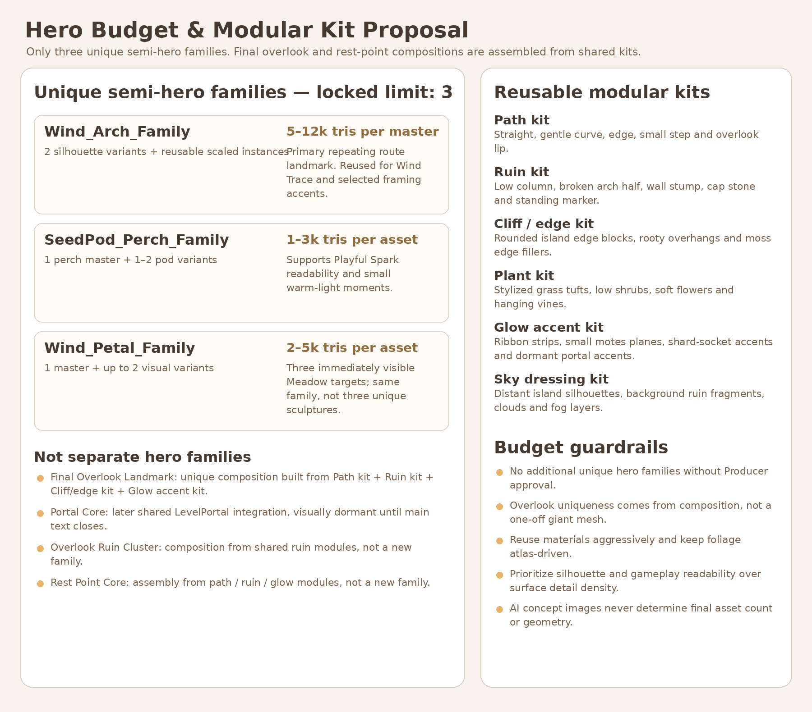
Approved semi-hero/modular budget direction. This Bible locks the registry and removes Final Overlook/Rest Point as separate hero families.

Document completion statement - Version 1.1
COMPLETE - v1.1
This document is the self-contained Art Production Bible v1.1 for Level_03. It normalizes the full registry and exact paths, separates GB-P0 from post-greybox art priorities, locks EnvironmentRoot ownership of the hard boundary belt, defines universal dimension/transform contracts, splits visual and collision replacement gates, locks zero movement and art tolerance, resolves SoulOrb_Follow reuse, and re-exports readable boundary maps. It creates no runtime or art assets and authorizes no implementation PR.

